Helpful communication Techniques Between Families and ELP Teachers (Full)

# 1. Mod 1

## 1.1 Title

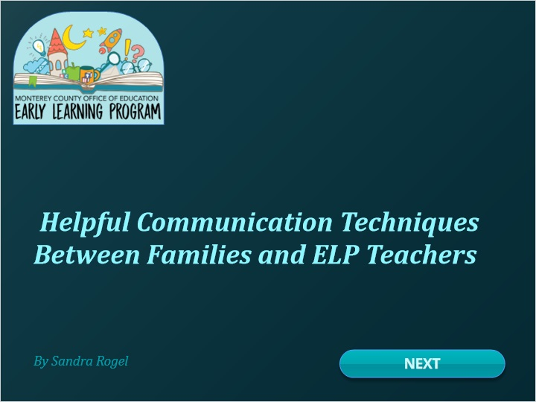

## 1.2 Pre assessment

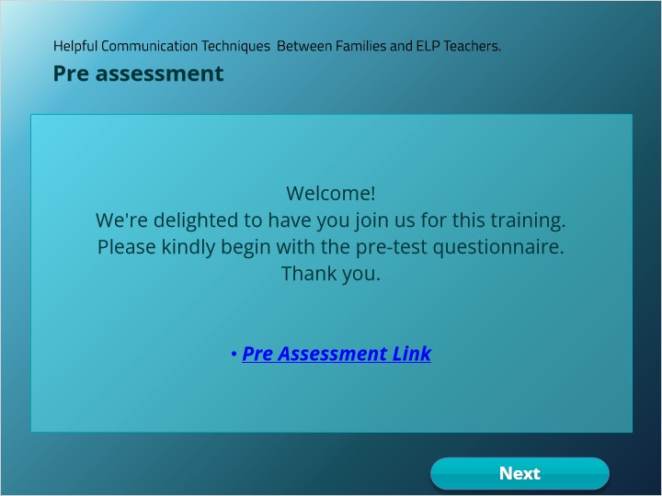

## 1.3 Introduction

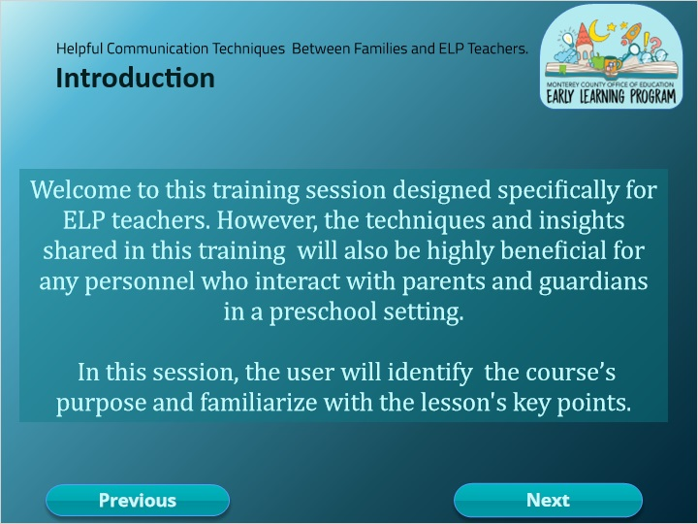

## 1.4 Course Purpose

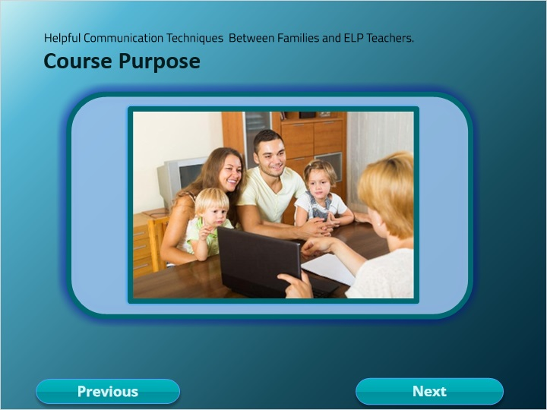

## 1.5 Course Structure

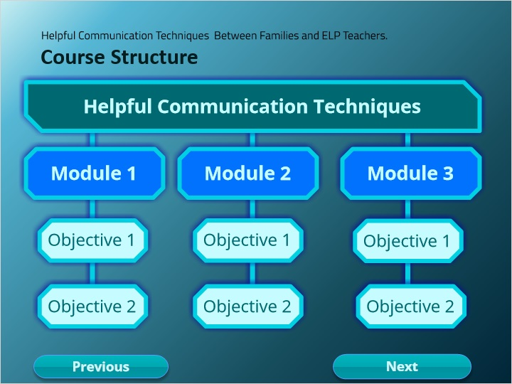

## 1.6 Learning Objective 1

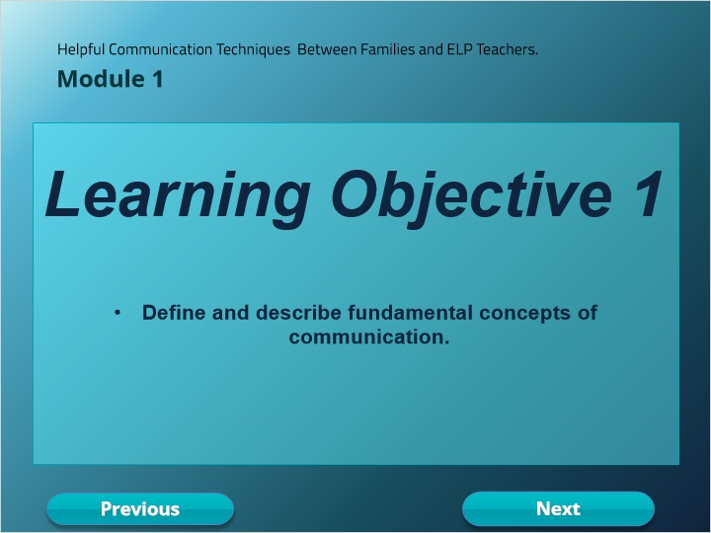

## 1.7 Importance of Communication in Schools

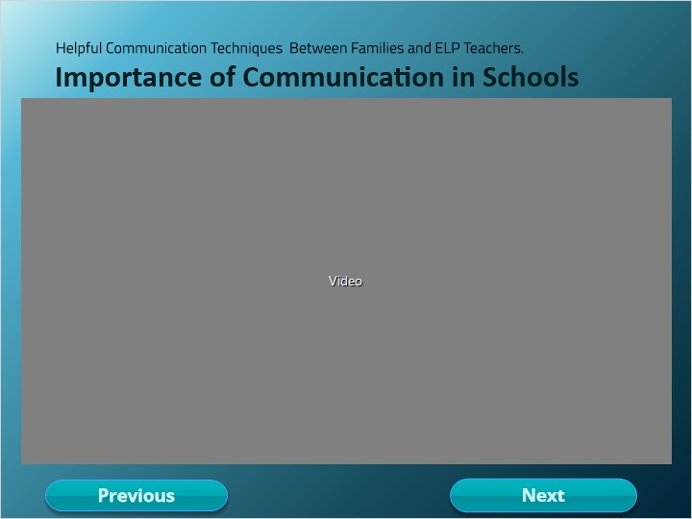

**Notes:**

## 1.8 Quiz

*(Pick One, 10 points, 2 attempts permitted)*

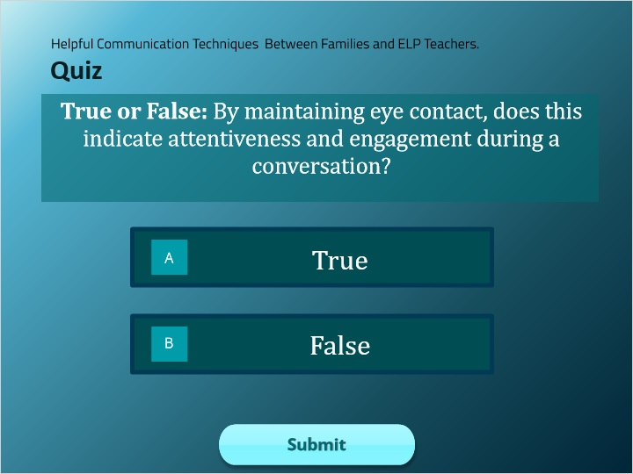

| Correct | Choice |
| --- | --- |
| Rectangle 1 | X |
| Rectangle 2 |  |

**Feedback when correct:**

That's right! You selected the correct response.

**Feedback when incorrect:**

You did not select the correct response.

**Notes:**

### Try Again (Slide Layer)

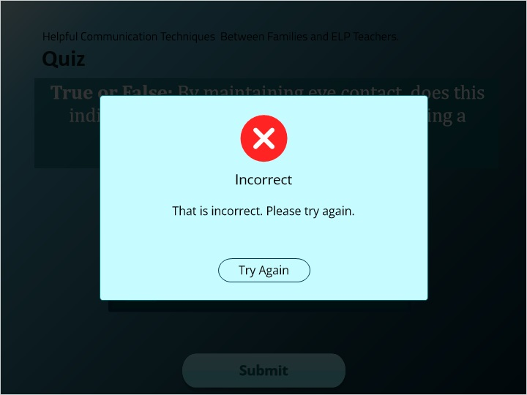

### Incorrect (Slide Layer)

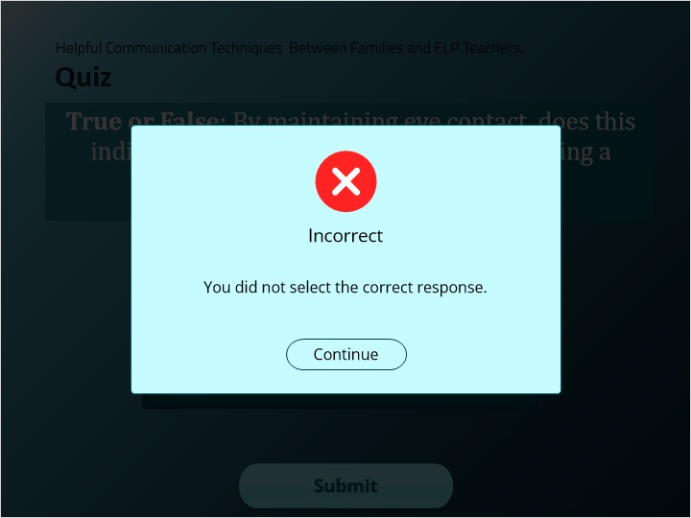

### Correct (Slide Layer)

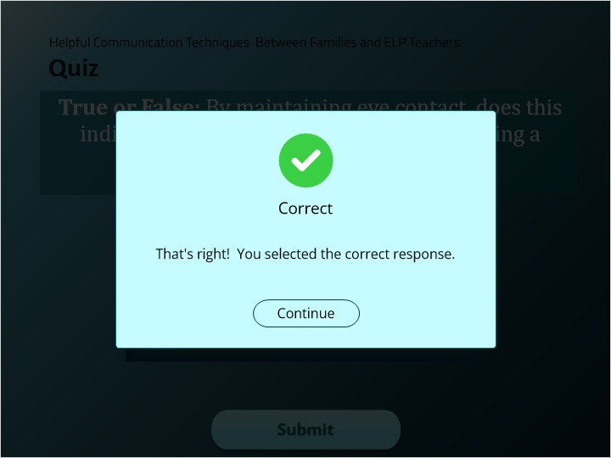

## 1.9 Art Of Communication

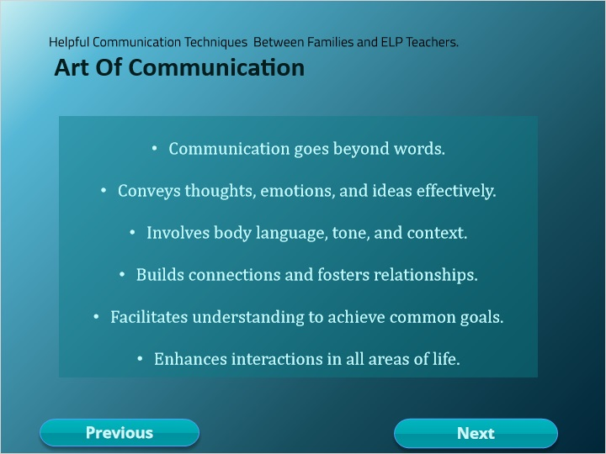

## 1.10 Quiz

*(Pick One, 10 points, 2 attempts permitted)*

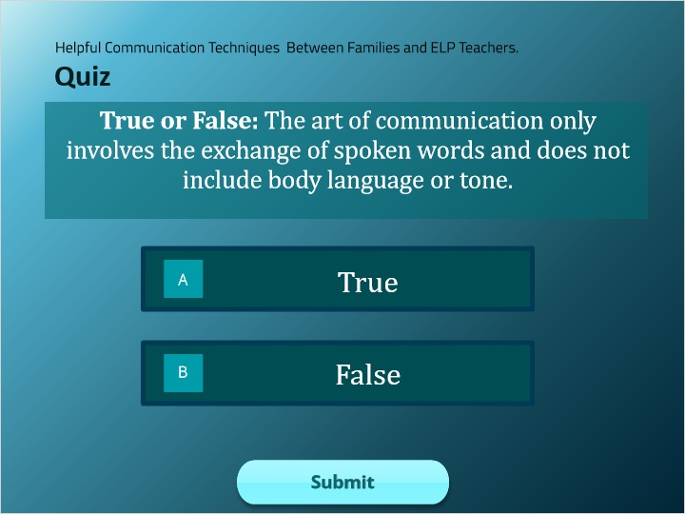

| Correct | Choice |
| --- | --- |
| Rectangle 1 |  |
| Rectangle 2 | X |

**Feedback when correct:**

That's right! You selected the correct response.

**Feedback when incorrect:**

You did not select the correct response.

**Notes:**

### Try Again (Slide Layer)

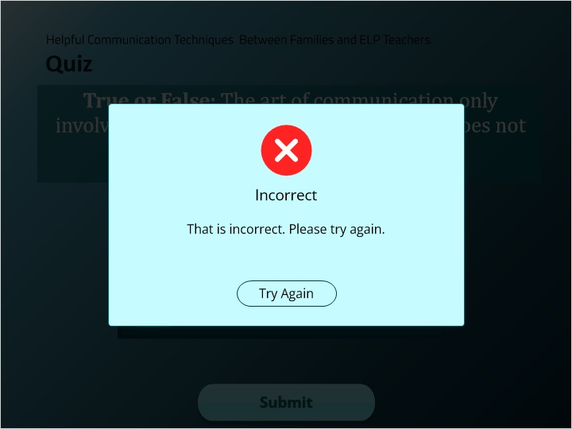

### Incorrect (Slide Layer)

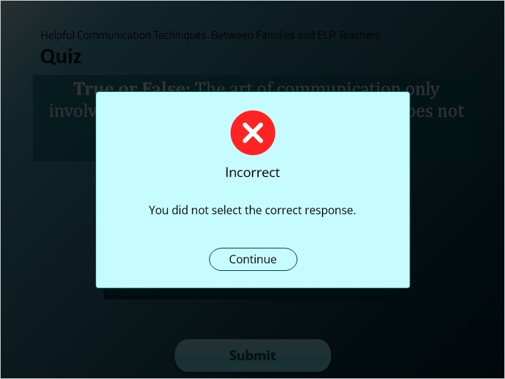

### Correct (Slide Layer)

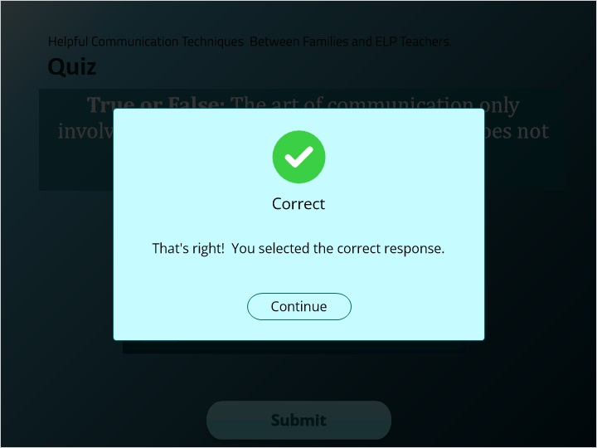

## 1.11 Quiz

*(Pick One, 10 points, 2 attempts permitted)*

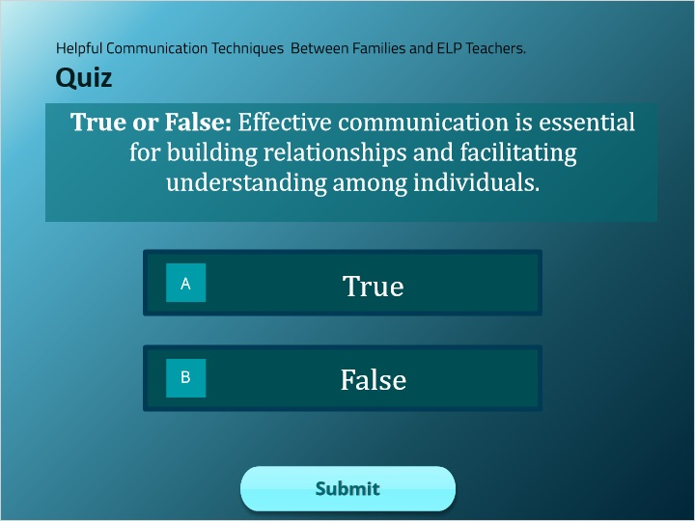

| Correct | Choice |
| --- | --- |
| Rectangle 1 | X |
| Rectangle 2 |  |

**Feedback when correct:**

That's right! You selected the correct response.

**Feedback when incorrect:**

You did not select the correct response.

**Notes:**

### Try Again (Slide Layer)

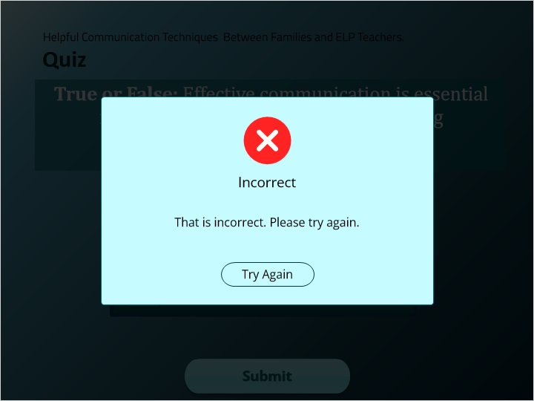

### Incorrect (Slide Layer)

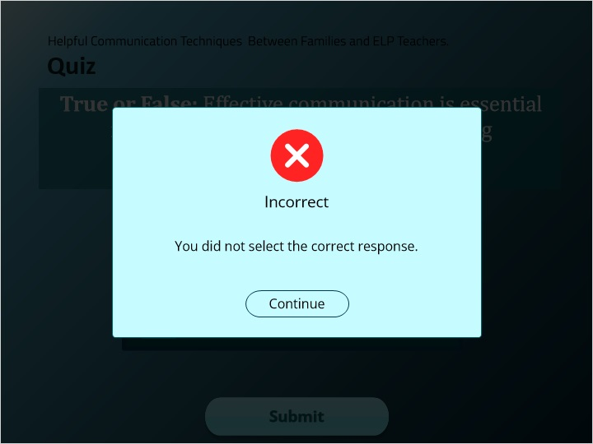

### Correct (Slide Layer)

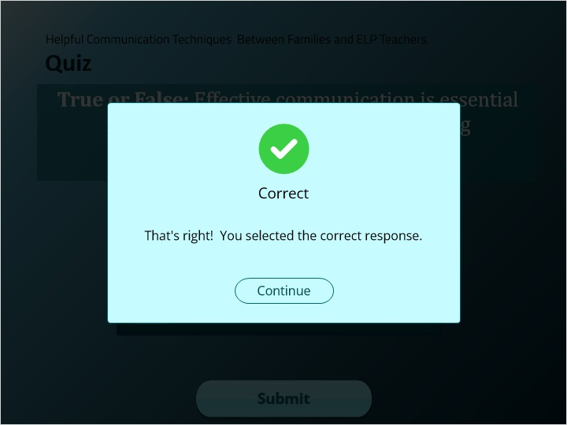

## 1.12 Meaningful Communication.

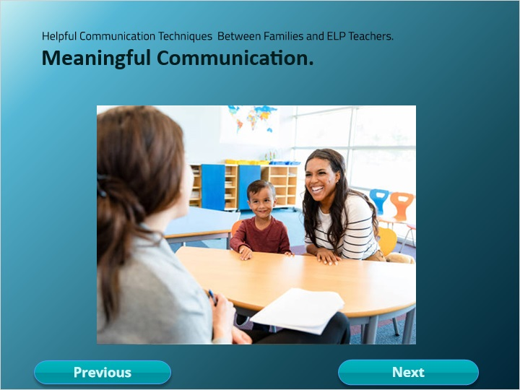

## 1.13 Basic Communication Skills

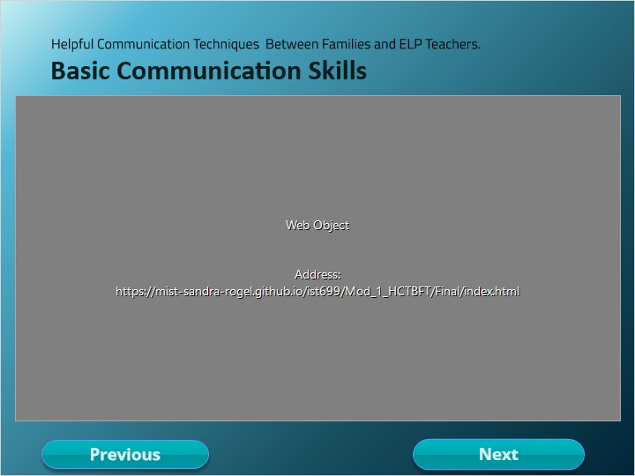

**Notes:**

## 1.14 Module 1

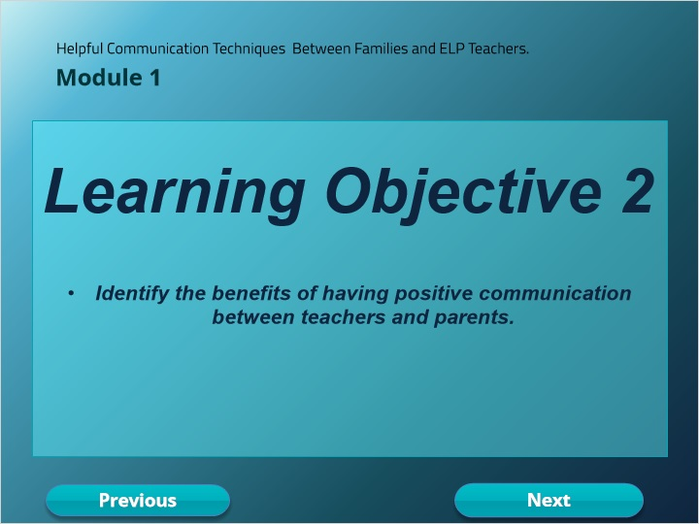

## 1.15 Benefits of Positive Communication

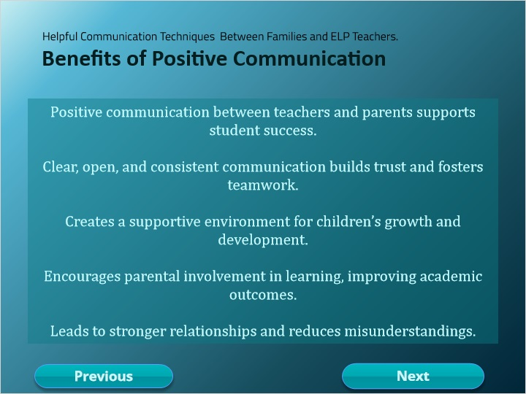

**Notes:**

## 1.16 Benefits of Positive Communication

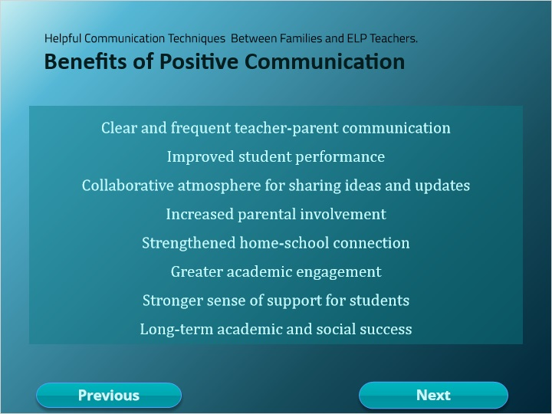

**Notes:**

## 1.17 Quiz

*(Pick One, 10 points, 2 attempts permitted)*

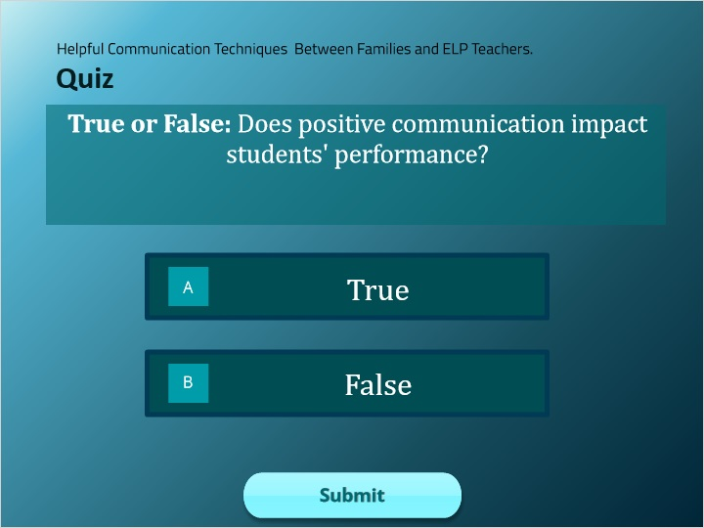

| Correct | Choice |
| --- | --- |
| Rectangle 1 | X |
| Rectangle 2 |  |

**Feedback when correct:**

That's right! You selected the correct response.

**Feedback when incorrect:**

You did not select the correct response.

**Notes:**

### Try Again (Slide Layer)

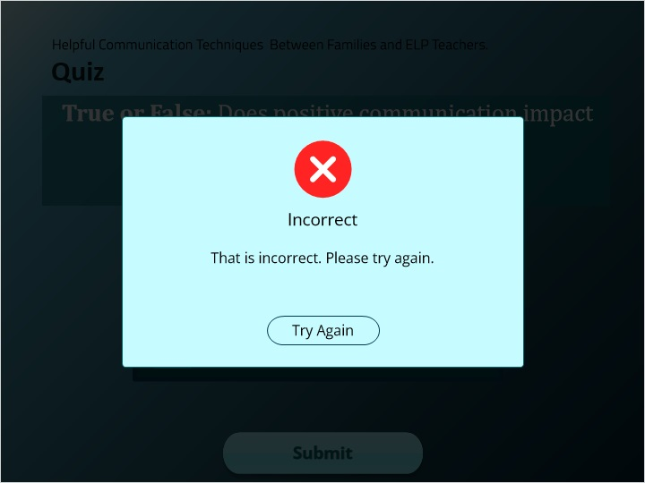

### Incorrect (Slide Layer)

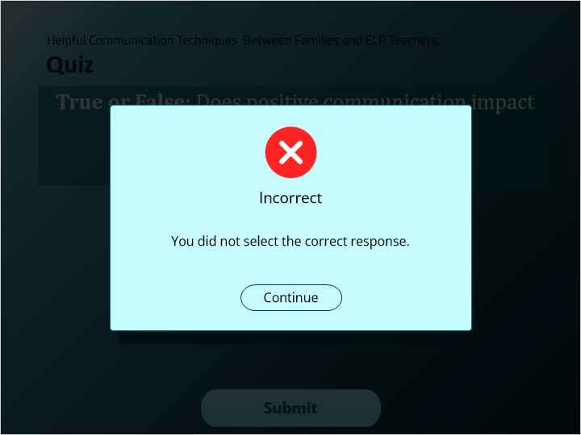

### Correct (Slide Layer)

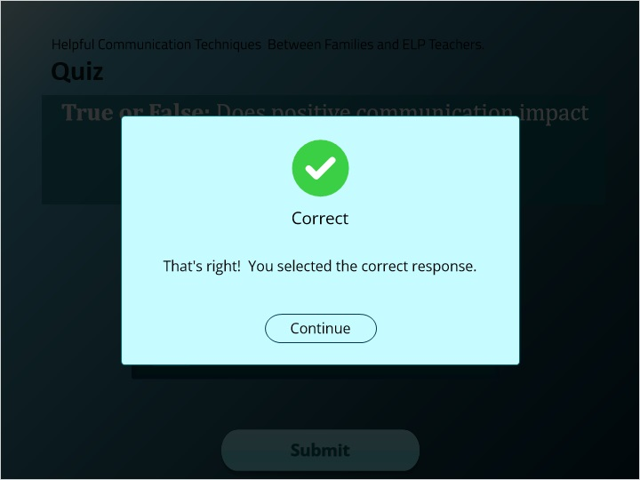

## 1.18 Positive Communication

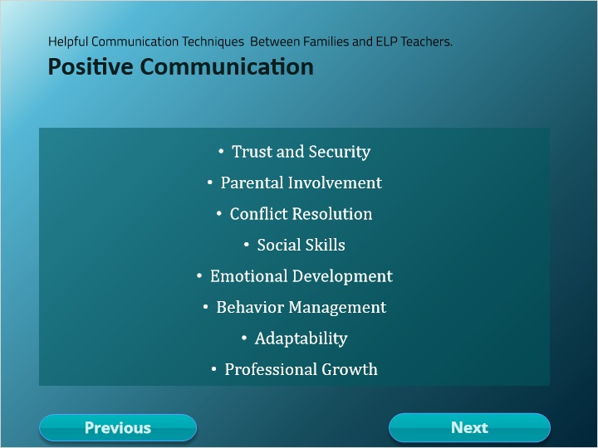

## 1.19 Importance of Good Relationships

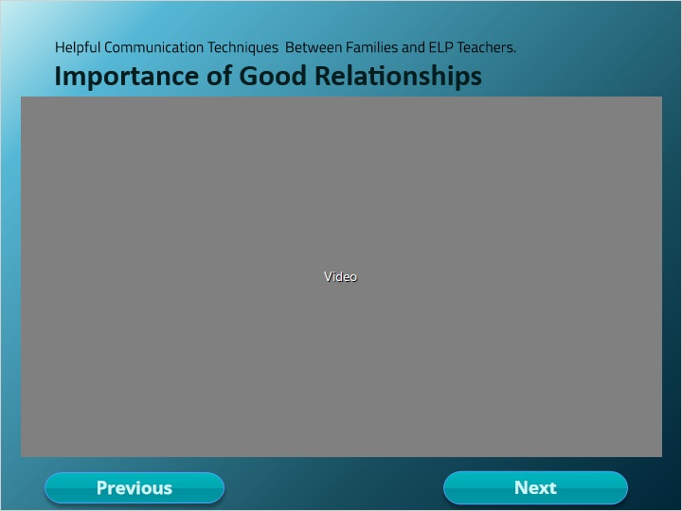

**Notes:**

## 1.20 Support Parents

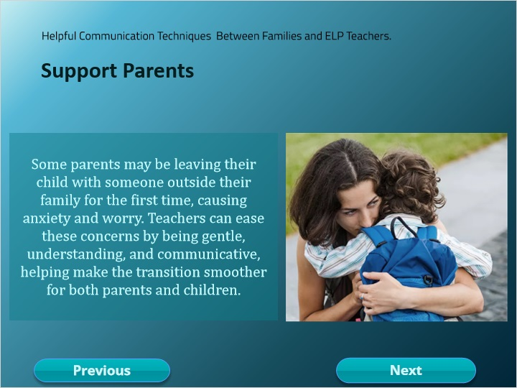

**Notes:**

## 1.21 Ensuring Parents Feel Safe

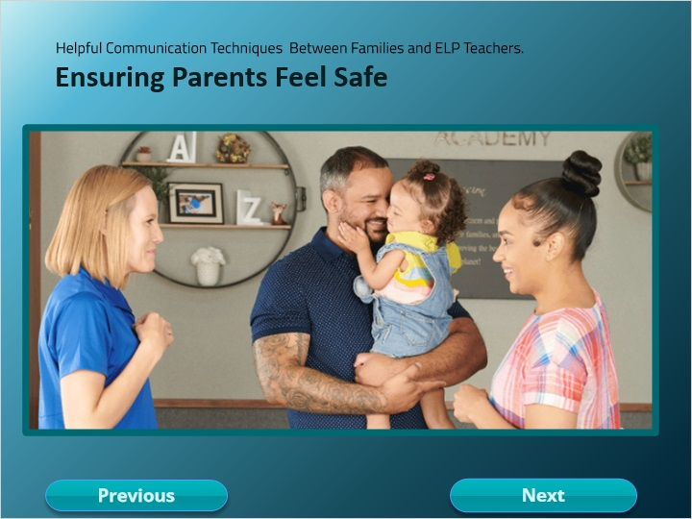

**Notes:**

## 1.22 Quiz

*(Pick One, 10 points, 2 attempts permitted)*

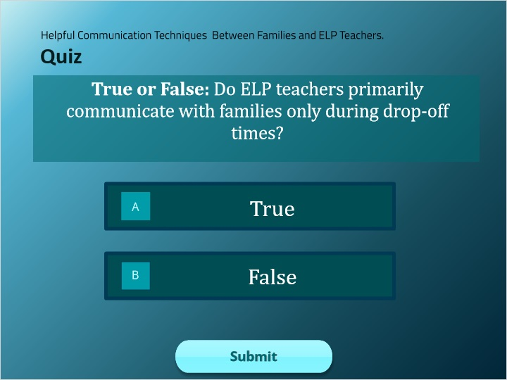

| Correct | Choice |
| --- | --- |
| Rectangle 1 |  |
| Rectangle 2 | X |

**Feedback when correct:**

That's right! You selected the correct response.

**Feedback when incorrect:**

You did not select the correct response.

**Notes:**

### Try Again (Slide Layer)

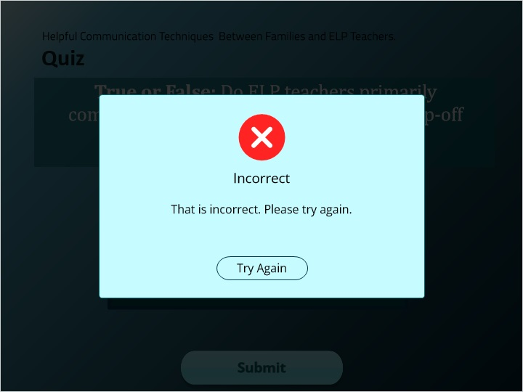

### Incorrect (Slide Layer)

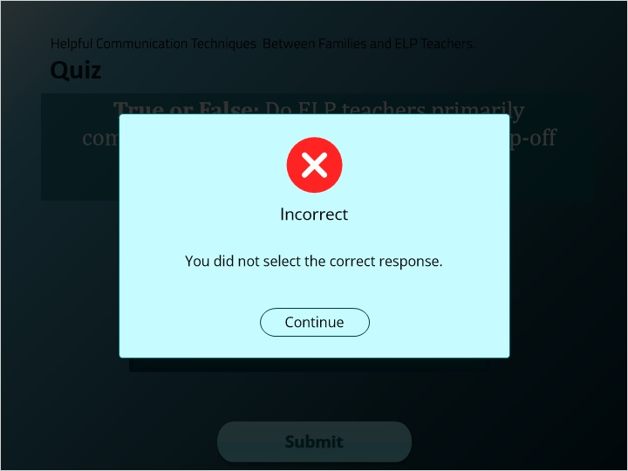

### Correct (Slide Layer)

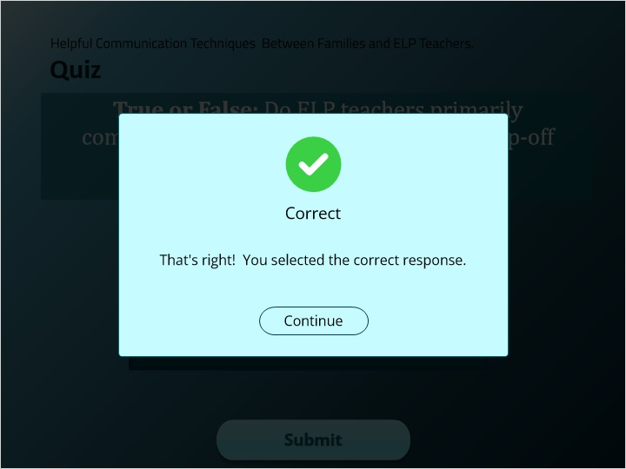

## 1.23 Quiz

*(Pick One, 10 points, 2 attempts permitted)*

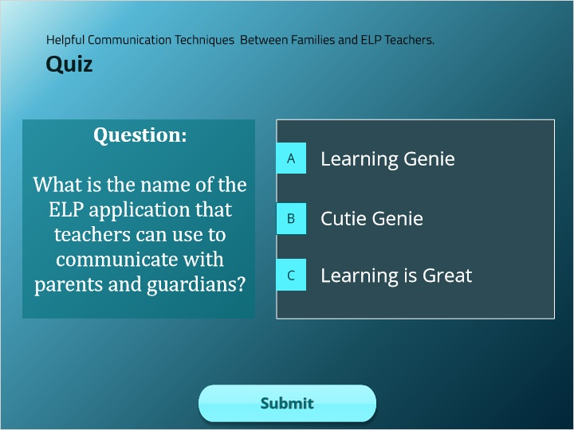

| Correct | Choice |
| --- | --- |
| Choice A | X |
| Choice B |  |
| Choice C |  |

**Feedback when correct:**

That's right! You selected the correct response.

**Feedback when incorrect:**

You did not select the correct response.

**Notes:**

### Try Again (Slide Layer)

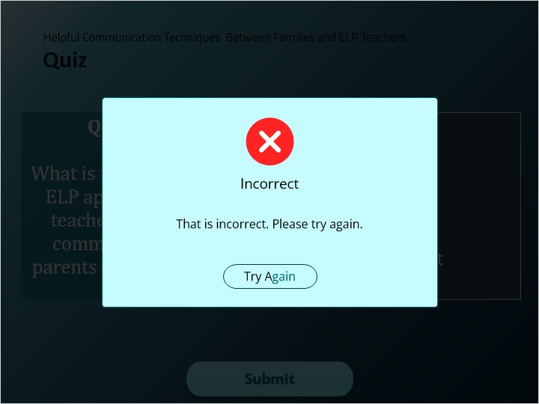

### Incorrect (Slide Layer)

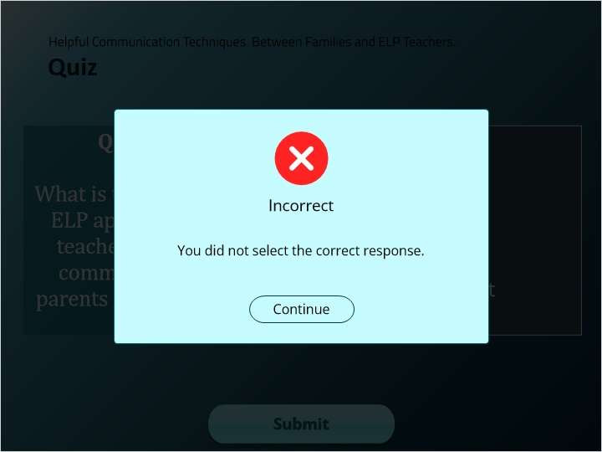

### Correct (Slide Layer)

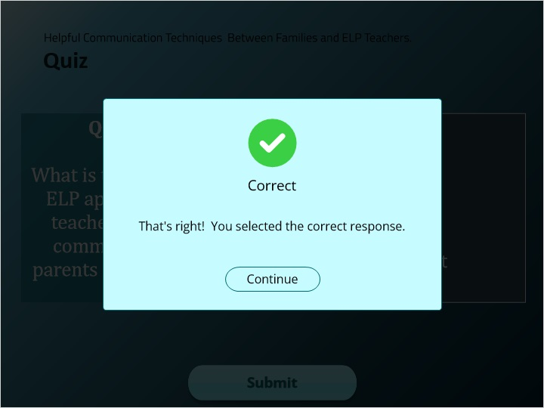

## 1.24 Quiz

*(Pick One, 10 points, 2 attempts permitted)*

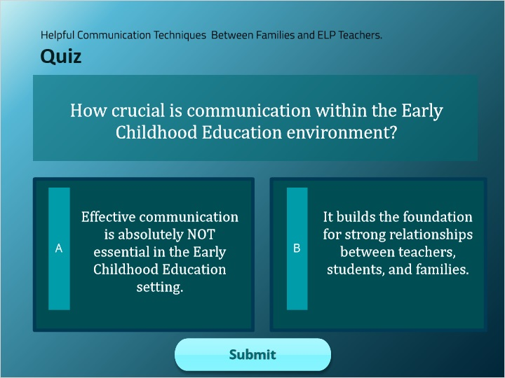

| Correct | Choice |
| --- | --- |
| Rectangle 1 |  |
| Rectangle 2 | X |

**Feedback when correct:**

That's right! You selected the correct response.

**Feedback when incorrect:**

You did not select the correct response.

**Notes:**

### Try Again (Slide Layer)

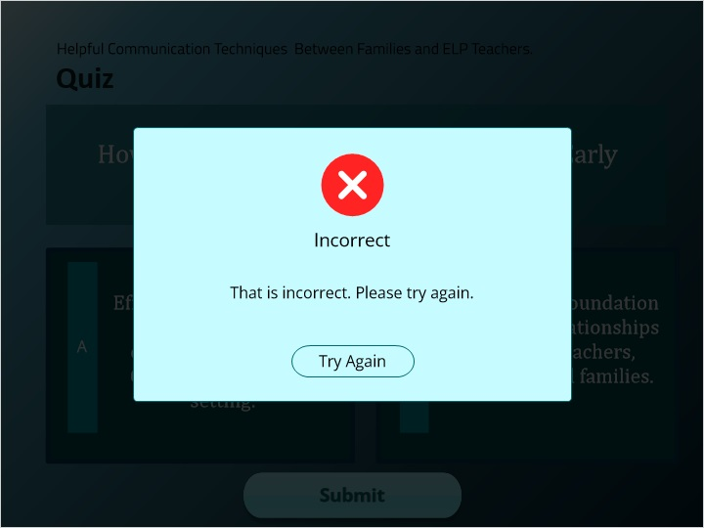

### Incorrect (Slide Layer)

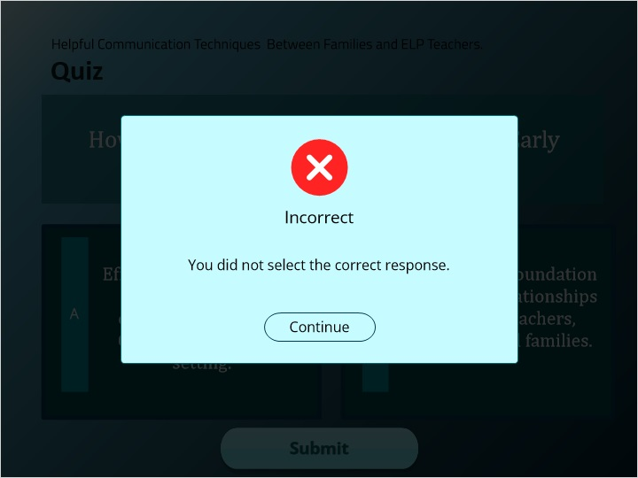

### Correct (Slide Layer)

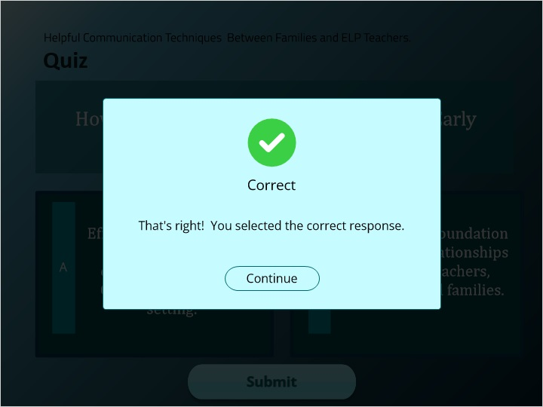

## 1.25 QUIZ RESULTS

*(Results Slide, 0 points, 1 attempt permitted)*

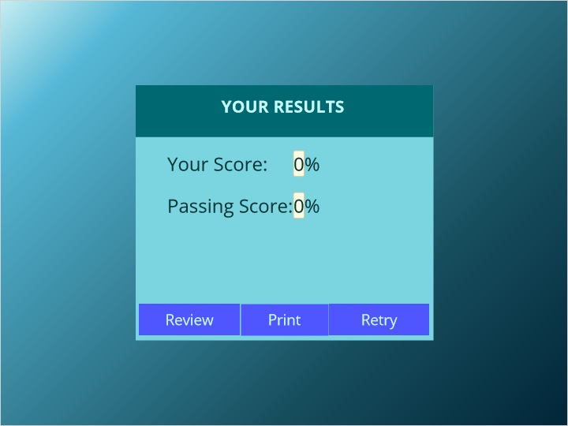

| Results for |
| --- |
| 1.8 Quiz |
| 1.10 Quiz |
| 1.11 Quiz |
| 1.17 Quiz |
| 1.22 Quiz |
| 1.23 Quiz |
| 1.24 Quiz |

| Result slide properties | Passing Score |
| --- | --- |
| 80% |

**Notes:**

### Failure (Slide Layer)

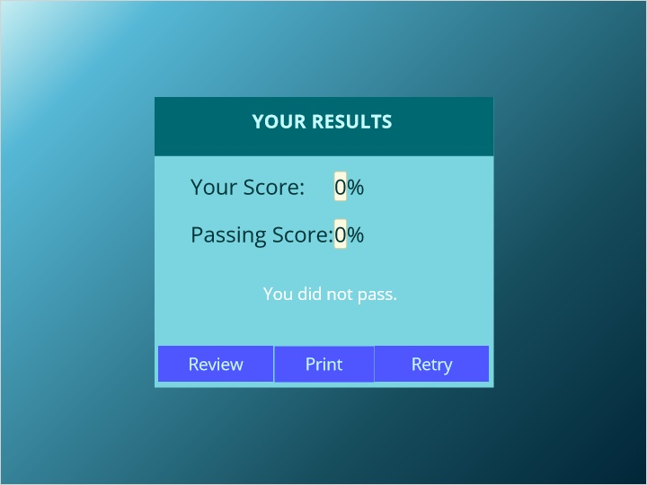

### Success (Slide Layer)

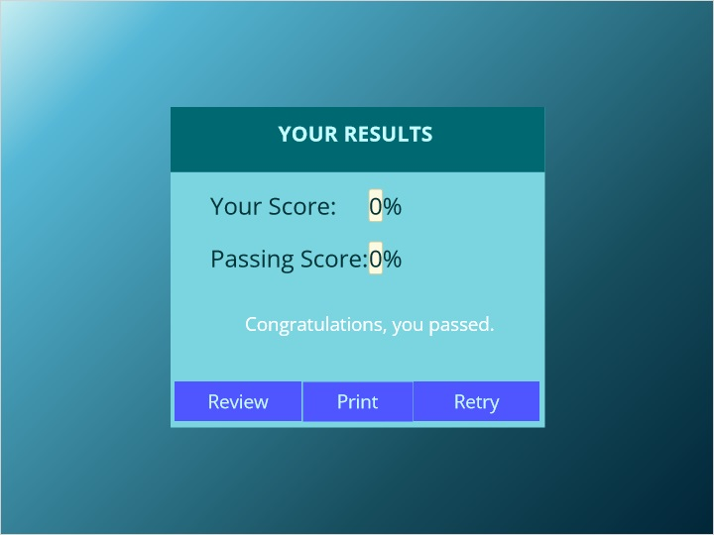

## 1.26 Ending

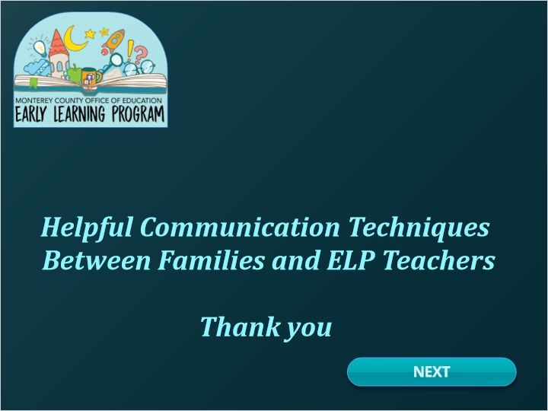

# 2. Mod 2

## 2.1 Title

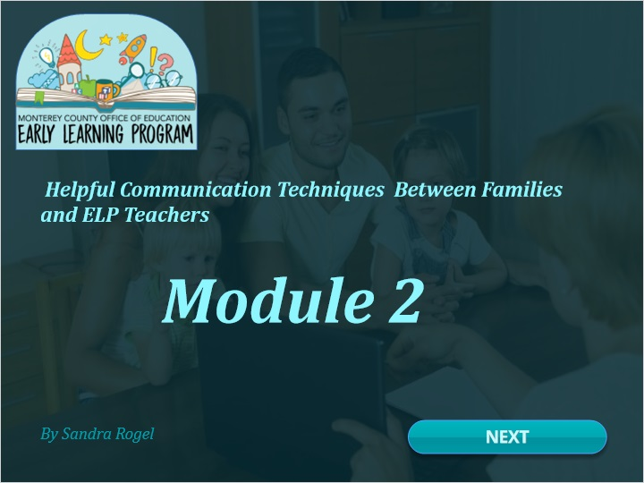

## 2.2 Course Structure

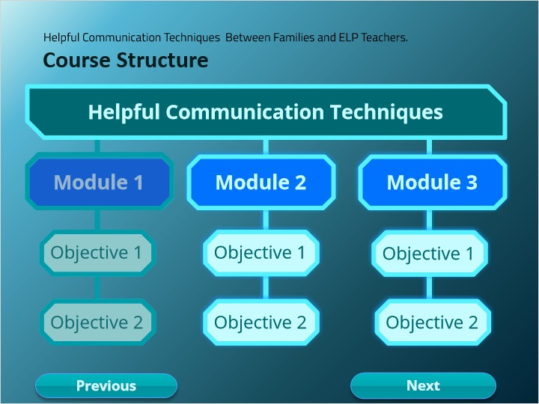

## 2.3 Learning Objectives 3 & 4

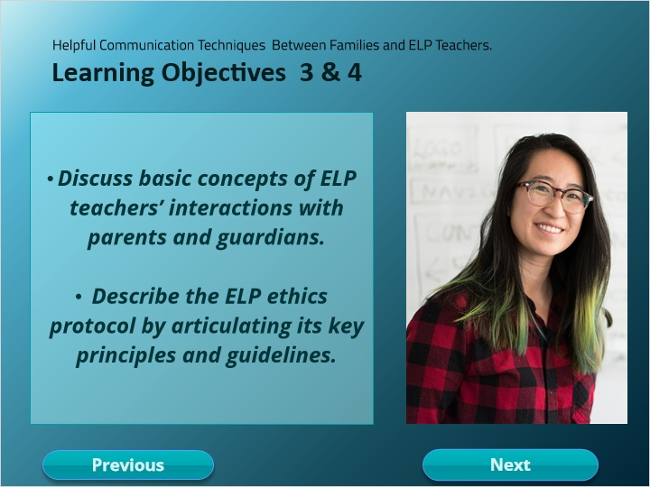

**Notes:**

## 2.4 Module 2

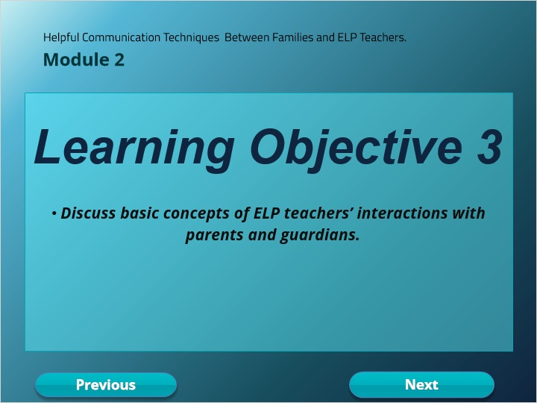

## 2.5 Interactions with Parents and Guardians

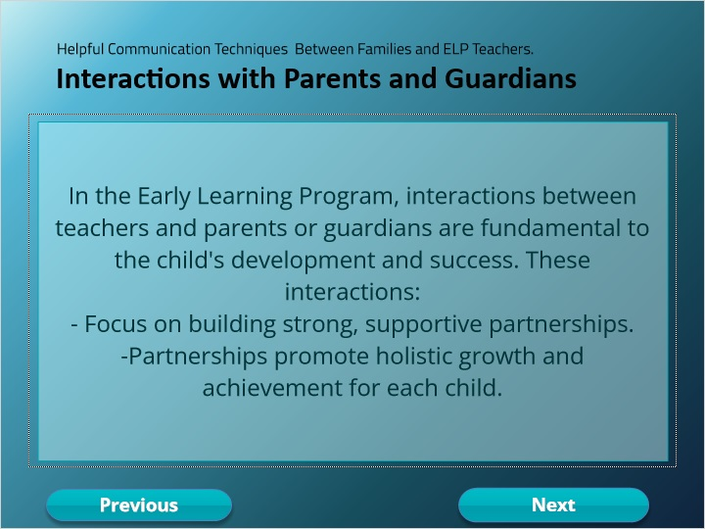

### Layer 1 (Slide Layer)

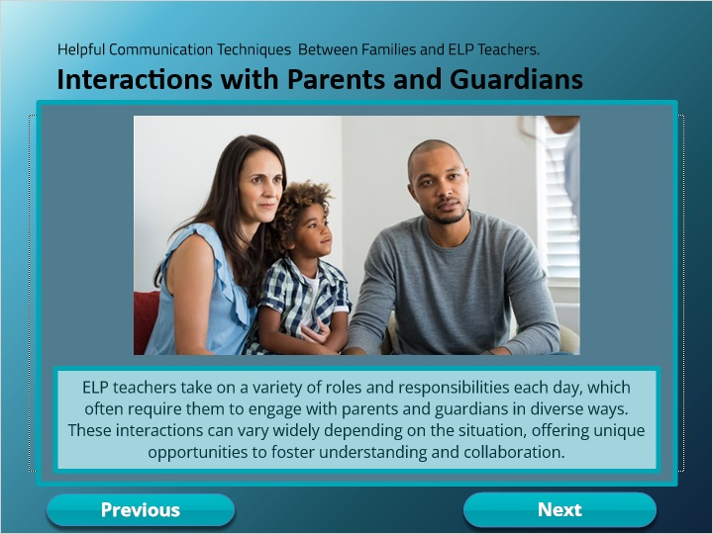

## 2.6 Scenarios

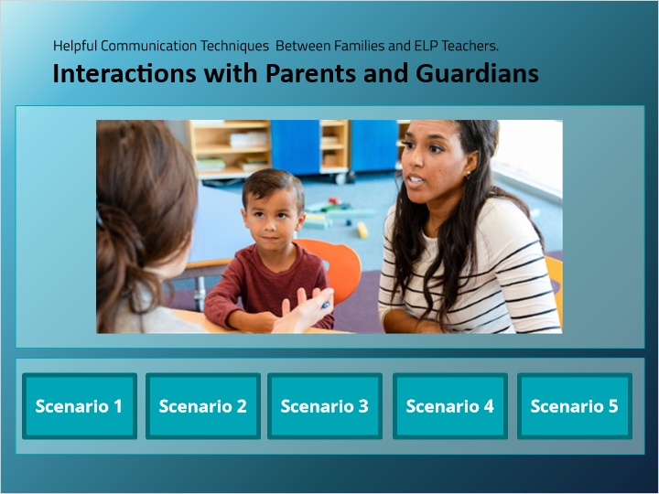

### Scenario 5 (Slide Layer)



### Scenario 4 (Slide Layer)



### Scenario 3 (Slide Layer)



### Scenario 2 (Slide Layer)



### Scenario 1 (Slide Layer)



## 2.7 Unsympathetic Scenario: Confrontation Without Support

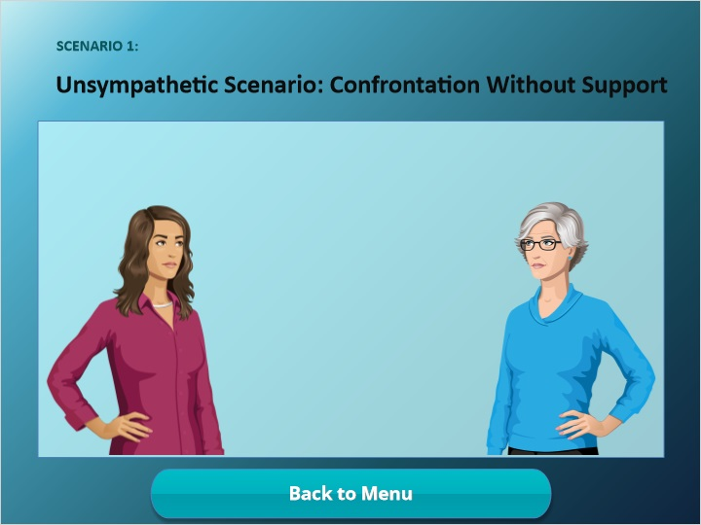

## 2.8 Using Pleasant and Supportive ELP Communication Practices:

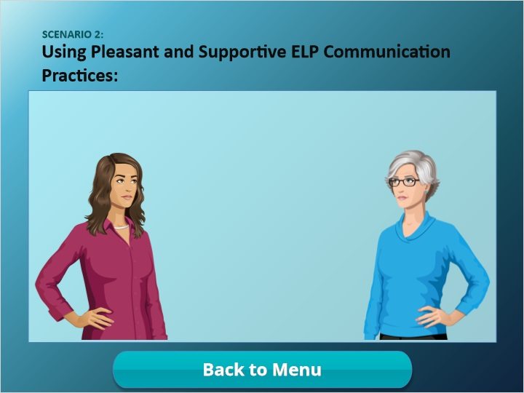

## 2.9 Unsympathetic Scenario: Incomplete Health Plan

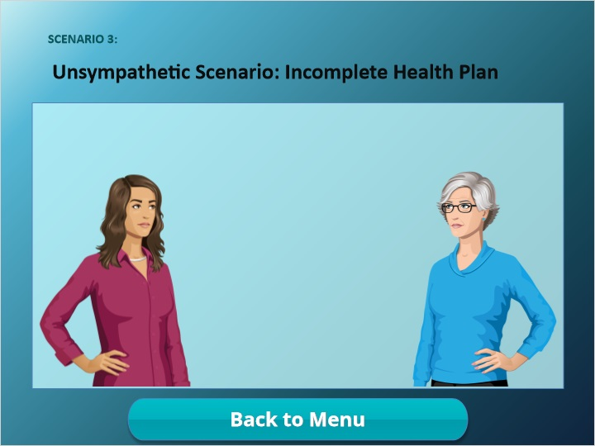

## 2.10 Upset Parent That Needs a Health Plan.

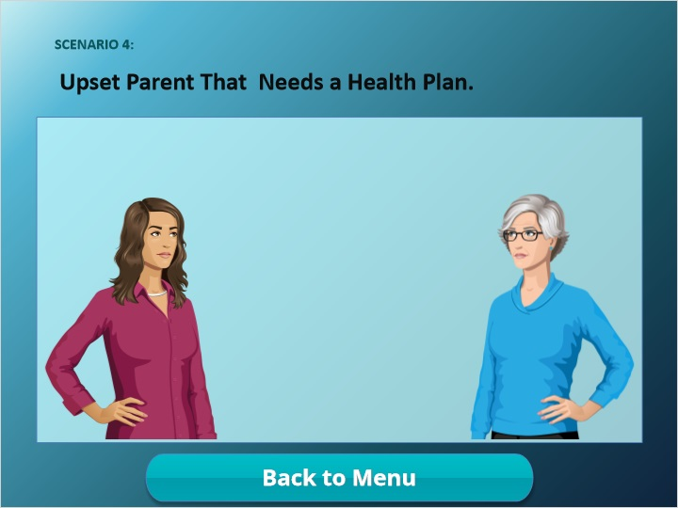

## 2.11 Grandparent request to change child’s emerging contacts

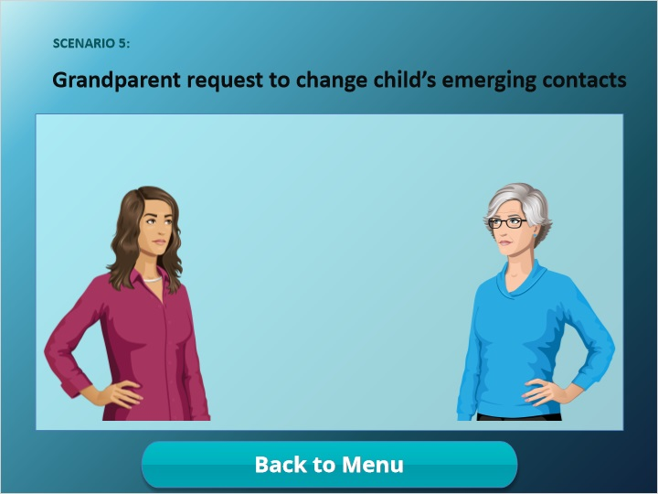

## 2.12 Interactions with Parents and Guardians

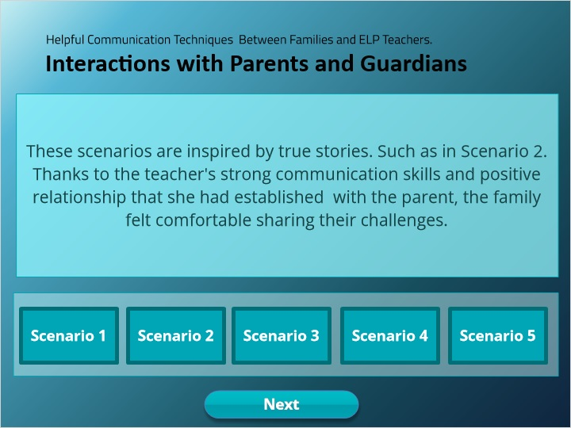

### Scenario 5 (Slide Layer)

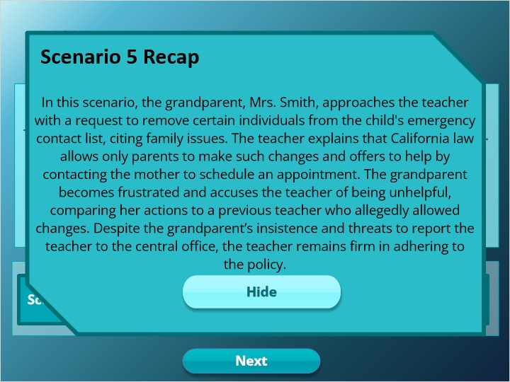

### Scenario 4 (Slide Layer)

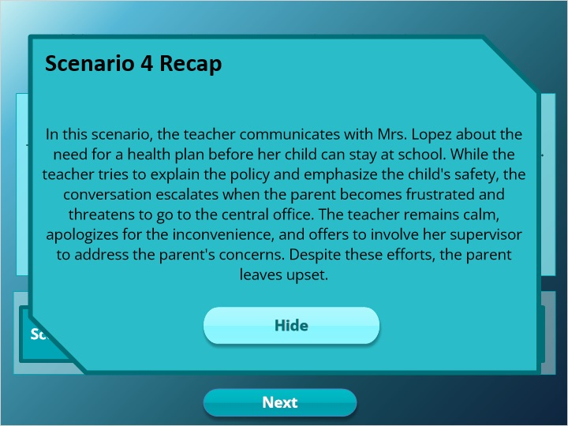

### Scenario 3 (Slide Layer)

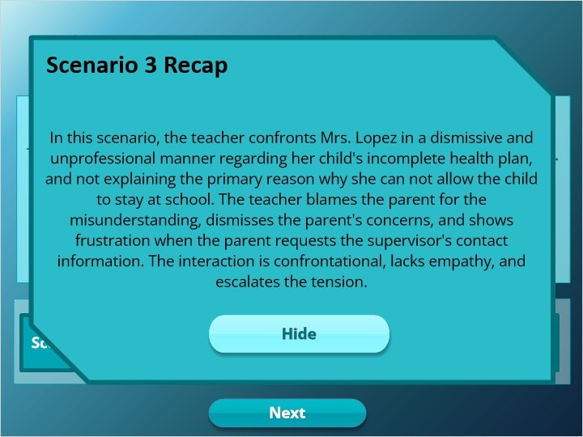

### Scenario 2 (Slide Layer)

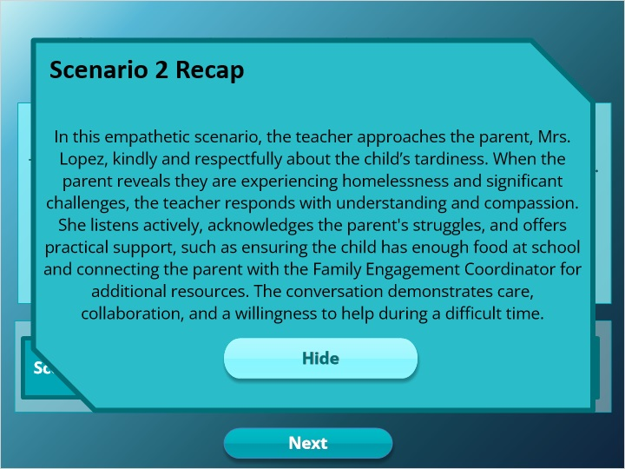

### Scenario 1 (Slide Layer)

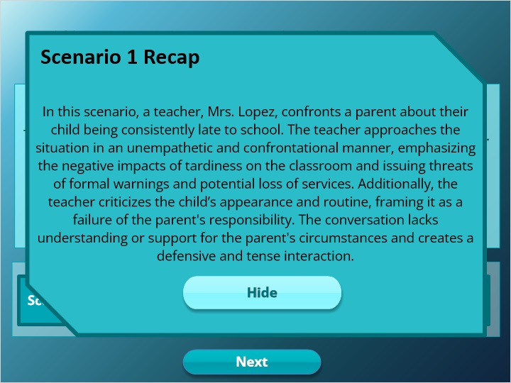

## 2.13 True or False

*(Pick One, 10 points, 2 attempts permitted)*

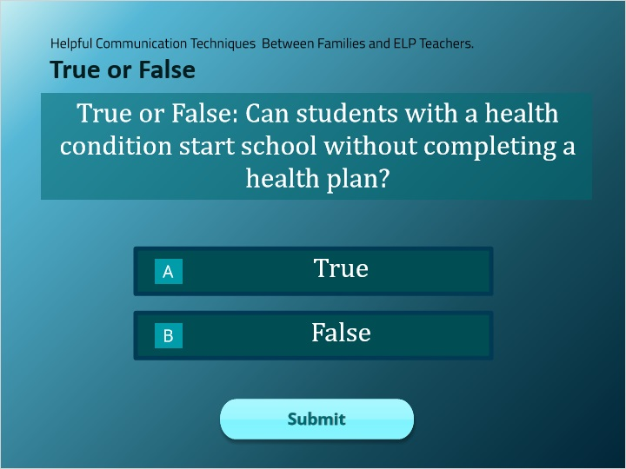

| Correct | Choice |
| --- | --- |
| Rectangle 1 |  |
| Rectangle 2 | X |

**Feedback when correct:**

That's right! You selected the correct response.

**Feedback when incorrect:**

You did not select the correct response.

**Notes:**

### Try Again (Slide Layer)

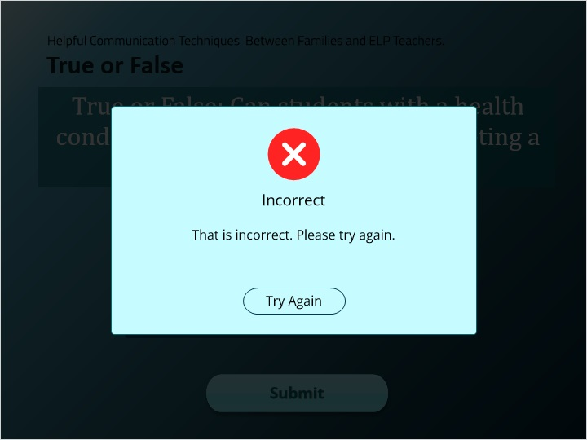

### Incorrect (Slide Layer)

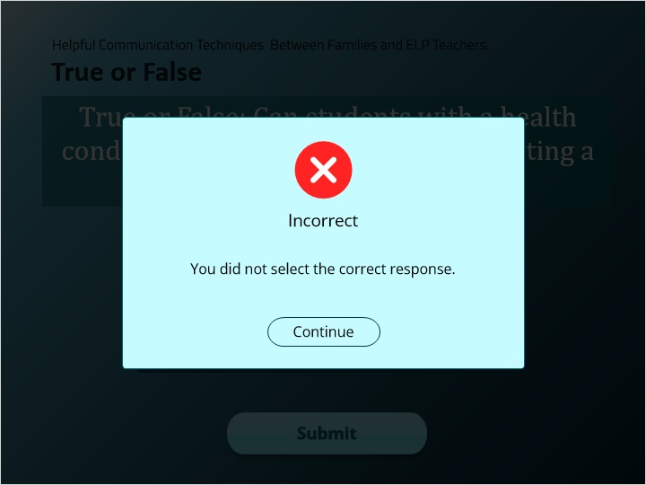

### Correct (Slide Layer)

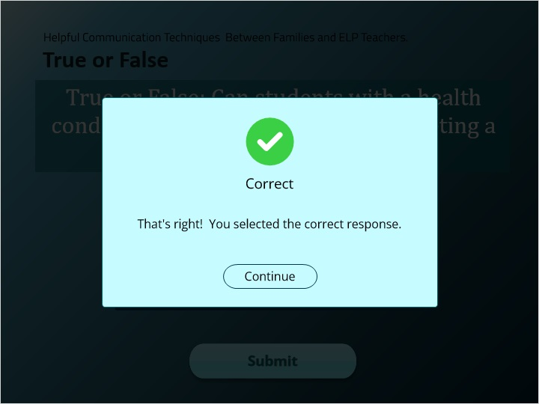

## 2.14 Quiz

*(Pick One, 10 points, 2 attempts permitted)*

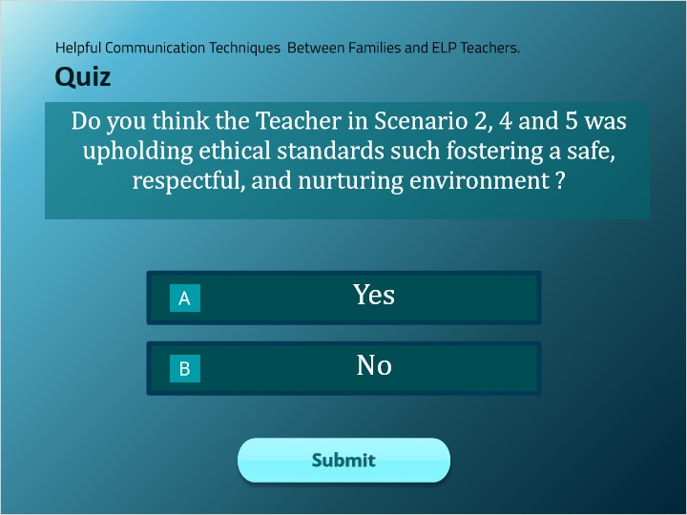

| Correct | Choice |
| --- | --- |
| Rectangle 1 | X |
| Rectangle 2 |  |

**Feedback when correct:**

That's right! You selected the correct response.

**Feedback when incorrect:**

You did not select the correct response.

**Notes:**

### Try Again (Slide Layer)

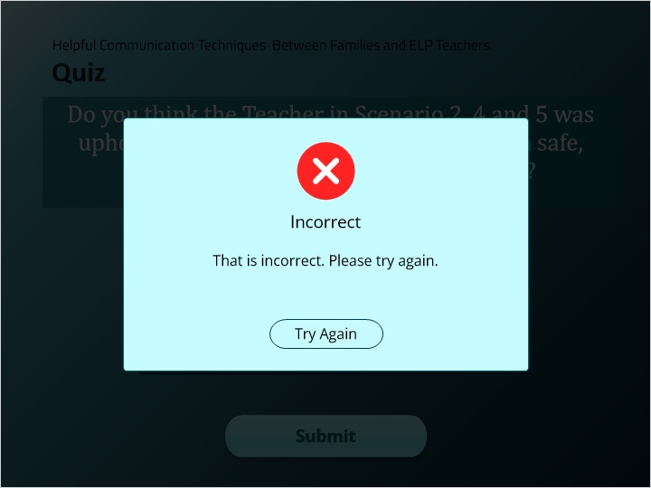

### Incorrect (Slide Layer)

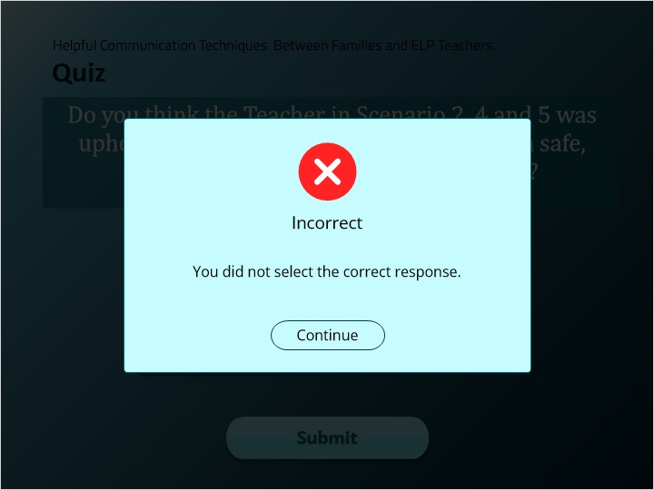

### Correct (Slide Layer)

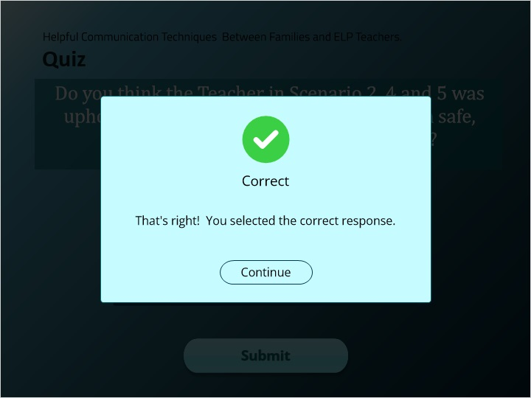

## 2.15 Quiz

*(Pick One, 10 points, 2 attempts permitted)*

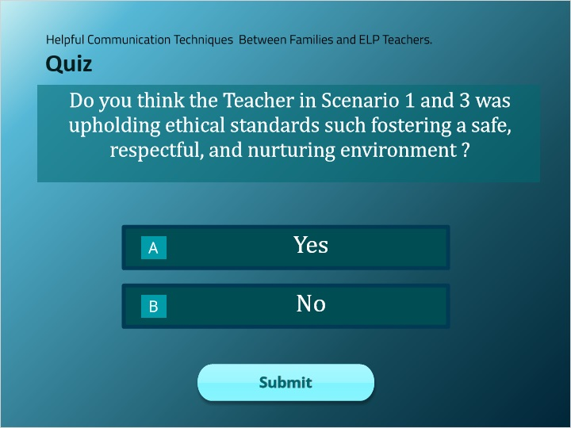

| Correct | Choice |
| --- | --- |
| Rectangle 1 |  |
| Rectangle 2 | X |

**Feedback when correct:**

That's right! You selected the correct response.

**Feedback when incorrect:**

You did not select the correct response.

**Notes:**

### Try Again (Slide Layer)

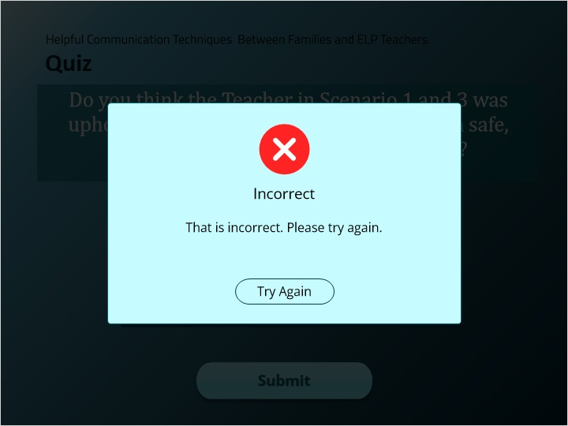

### Incorrect (Slide Layer)

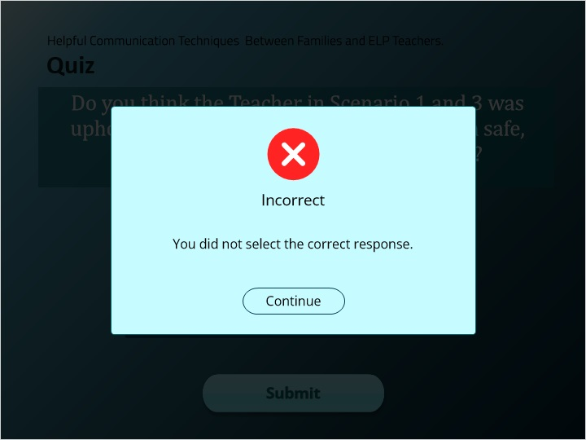

### Correct (Slide Layer)

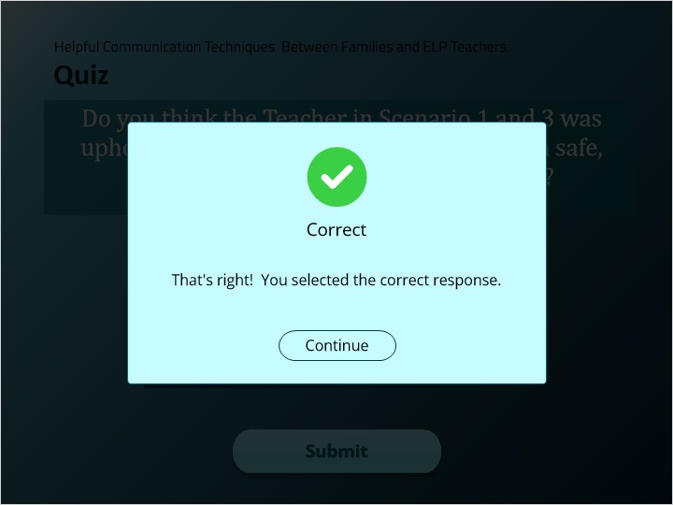

## 2.16 True or False

*(Pick One, 10 points, 2 attempts permitted)*

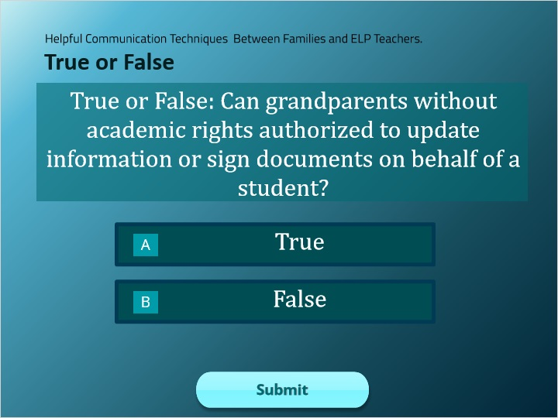

| Correct | Choice |
| --- | --- |
| Rectangle 1 |  |
| Rectangle 2 | X |

**Feedback when correct:**

That's right! You selected the correct response.

**Feedback when incorrect:**

You did not select the correct response.

**Notes:**

### Try Again (Slide Layer)

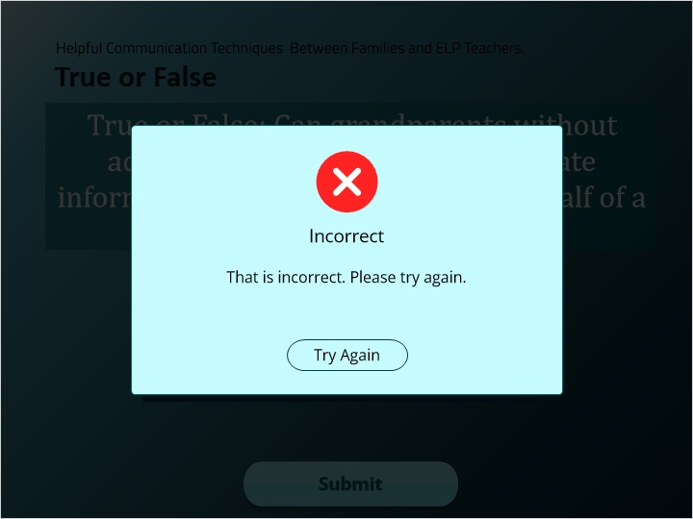

### Incorrect (Slide Layer)

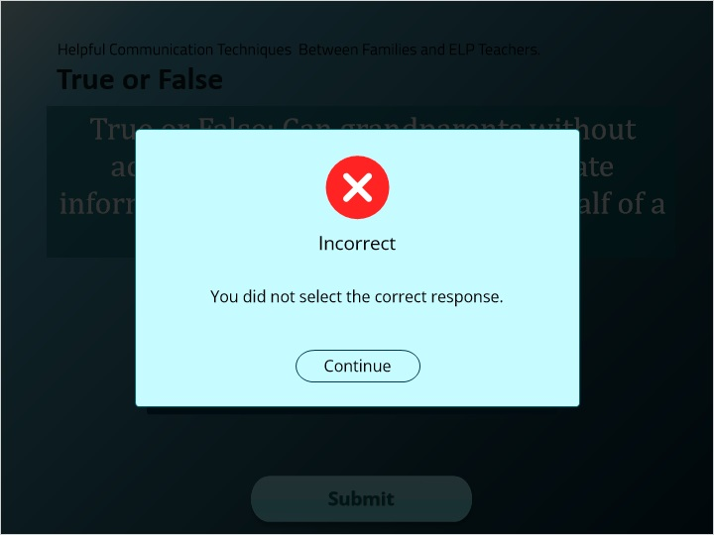

### Correct (Slide Layer)

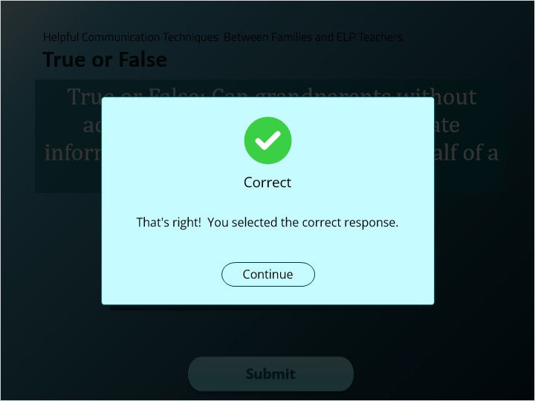

## 2.17 Module 2

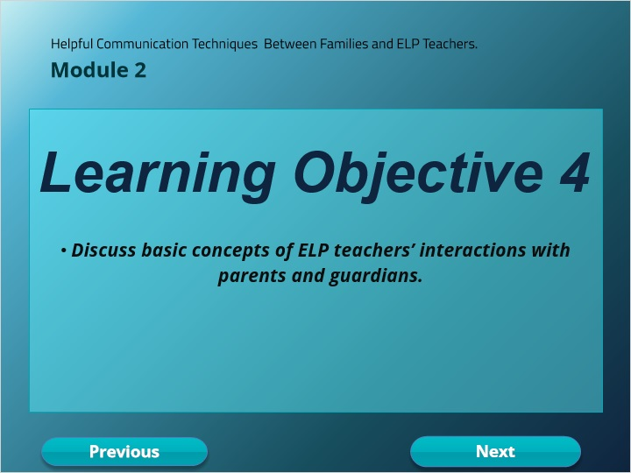

## 2.18 Introduction to ELP Key Principles

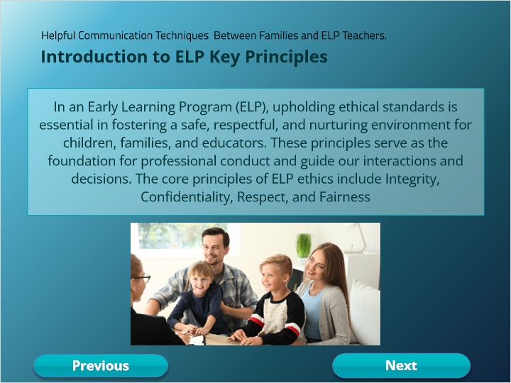

## 2.19 Key Principles

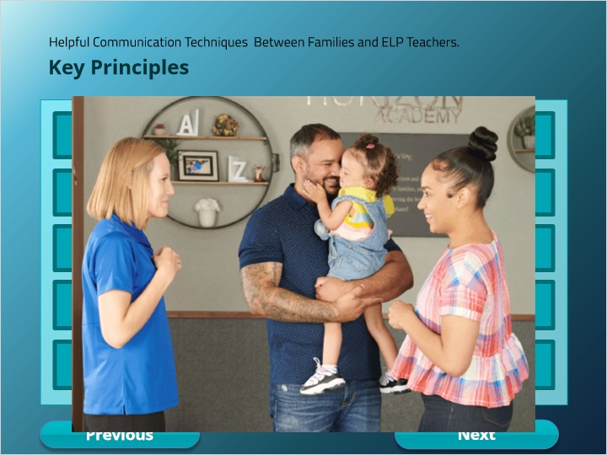

### Professionalism (Slide Layer)

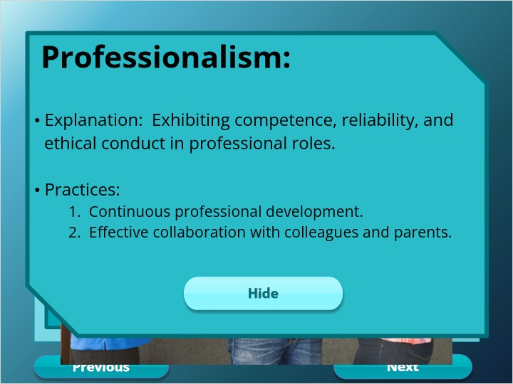

### Fairness (Slide Layer)

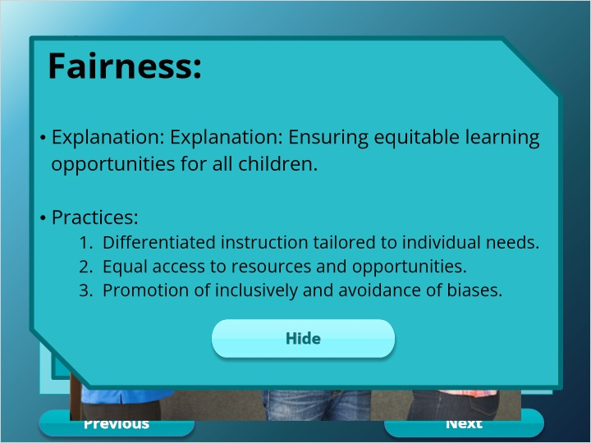

### Integrity (Slide Layer)

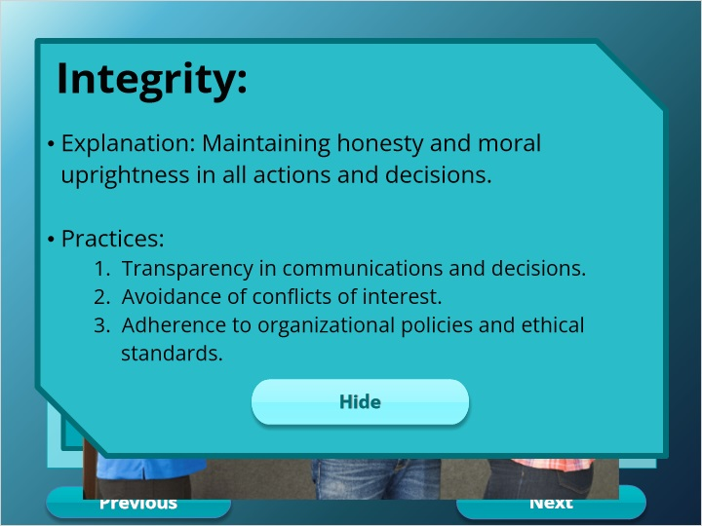

### Respect (Slide Layer)

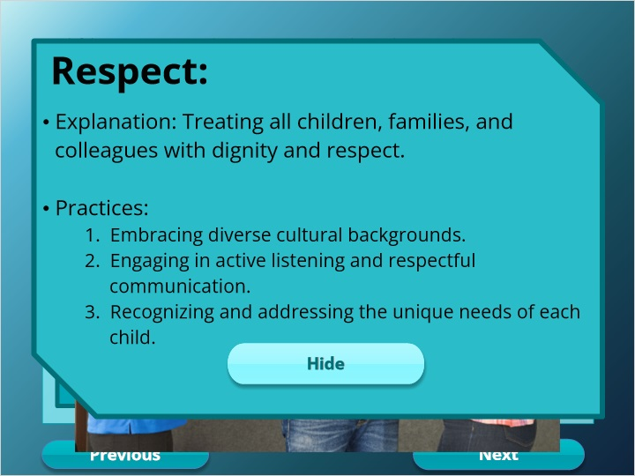

### Confidentiality (Slide Layer)

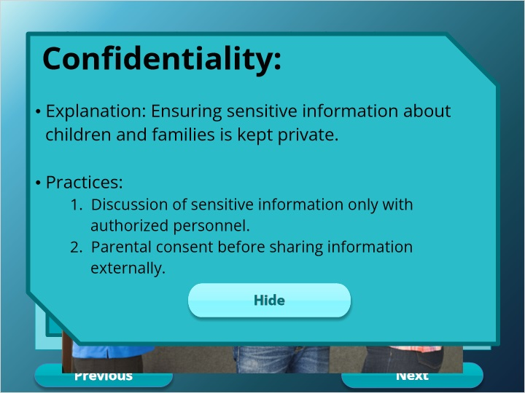

## 2.20 Code Ethics for Educators

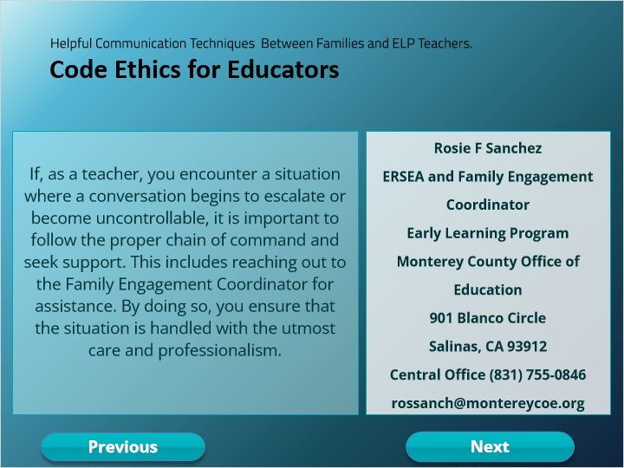

## 2.21 NEA

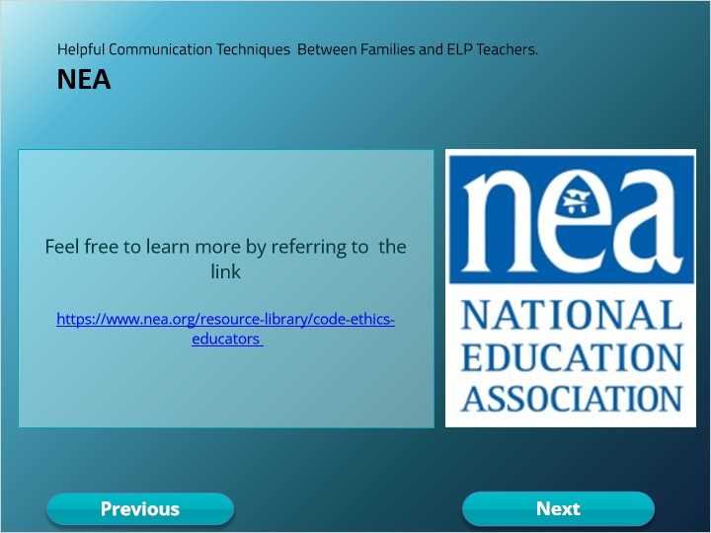

## 2.22 Quiz

*(Pick One, 10 points, 2 attempts permitted)*

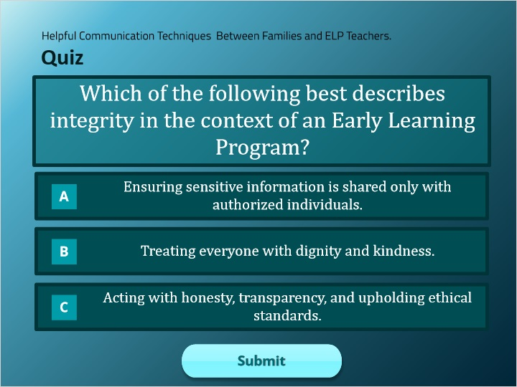

| Correct | Choice |
| --- | --- |
| Group 1 |  |
| Group 2 |  |
| Group 3 | X |

**Feedback when correct:**

That's right! You selected the correct response.

**Feedback when incorrect:**

You did not select the correct response.

**Notes:**

### Try Again (Slide Layer)

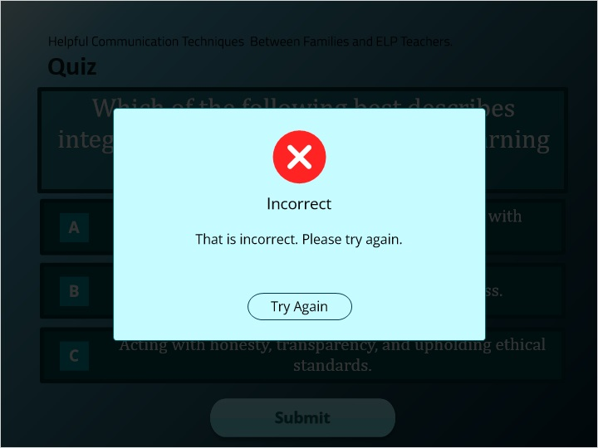

### Incorrect (Slide Layer)

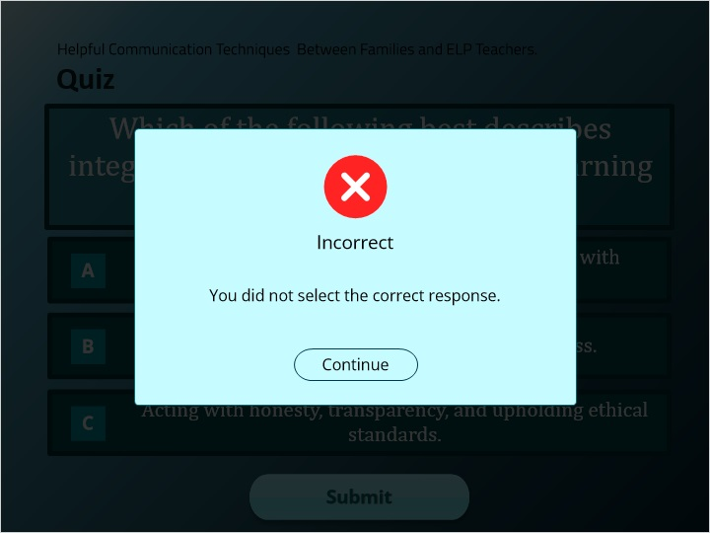

### Correct (Slide Layer)

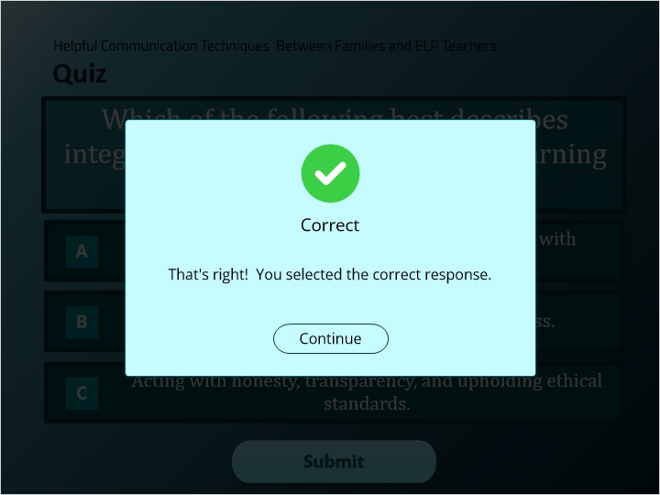

## 2.23 Quiz

*(Pick One, 10 points, 2 attempts permitted)*

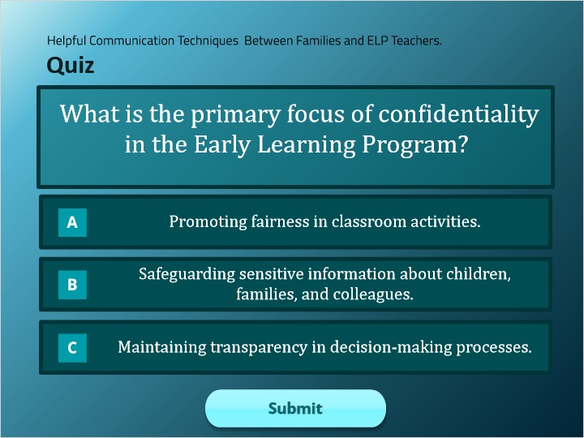

| Correct | Choice |
| --- | --- |
| Group 1 |  |
| Group 2 | X |
| Group 3 |  |

**Feedback when correct:**

That's right! You selected the correct response.

**Feedback when incorrect:**

You did not select the correct response.

**Notes:**

### Try Again (Slide Layer)

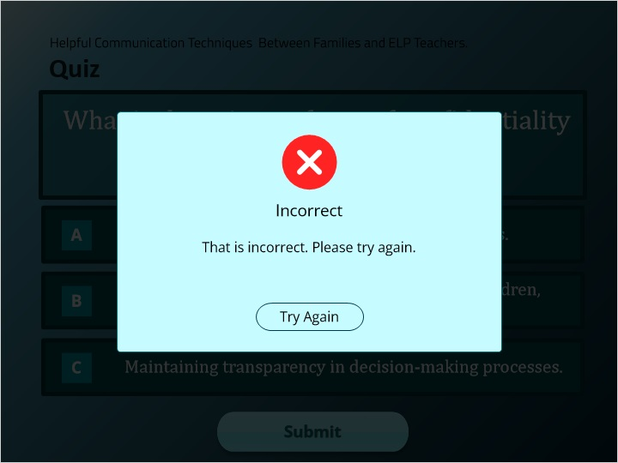

### Incorrect (Slide Layer)

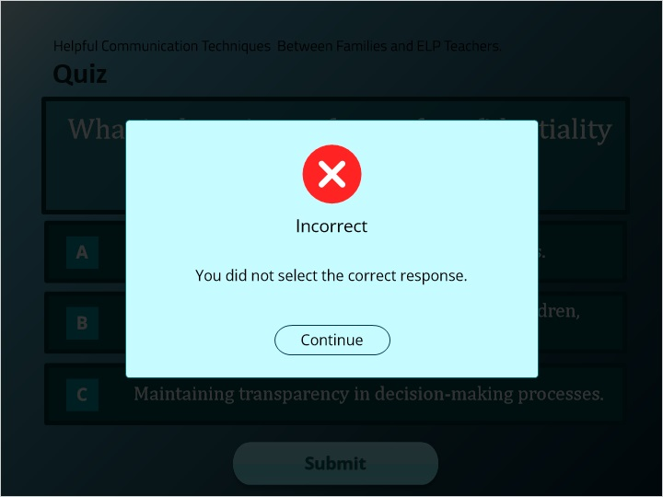

### Correct (Slide Layer)

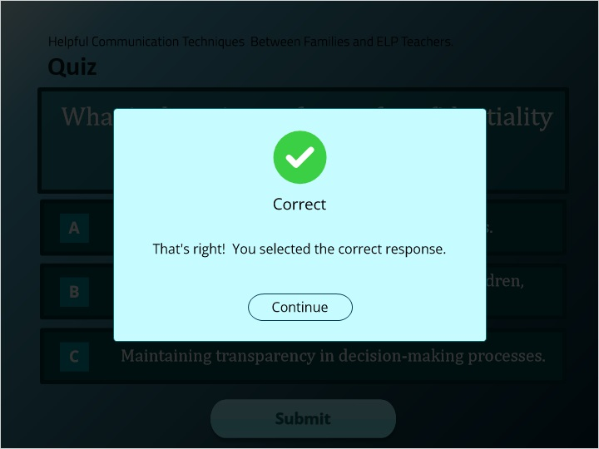

## 2.24 Quiz

*(Pick One, 10 points, 2 attempts permitted)*

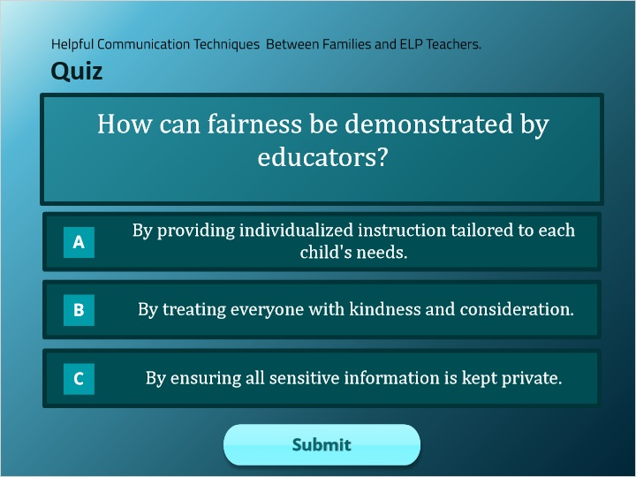

| Correct | Choice |
| --- | --- |
| Group 1 | X |
| Group 2 |  |
| Group 3 |  |

**Feedback when correct:**

That's right! You selected the correct response.

**Feedback when incorrect:**

You did not select the correct response.

**Notes:**

### Try Again (Slide Layer)

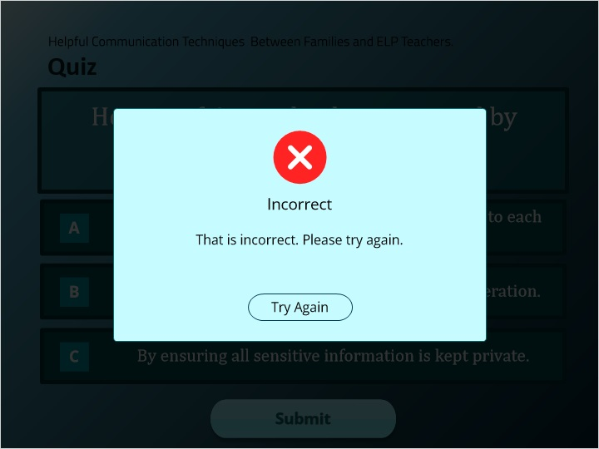

### Incorrect (Slide Layer)

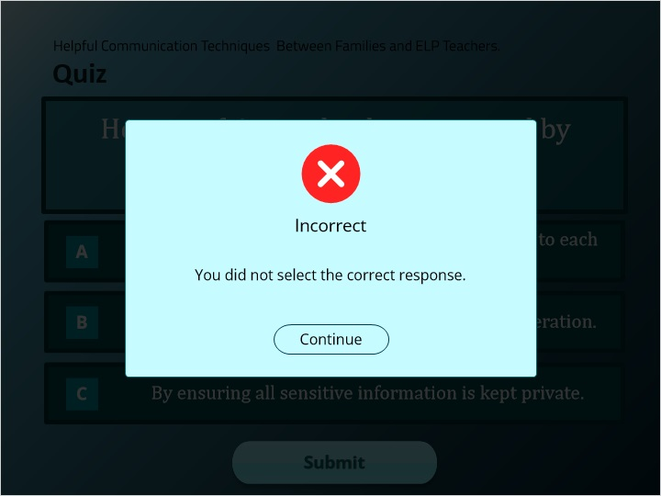

### Correct (Slide Layer)

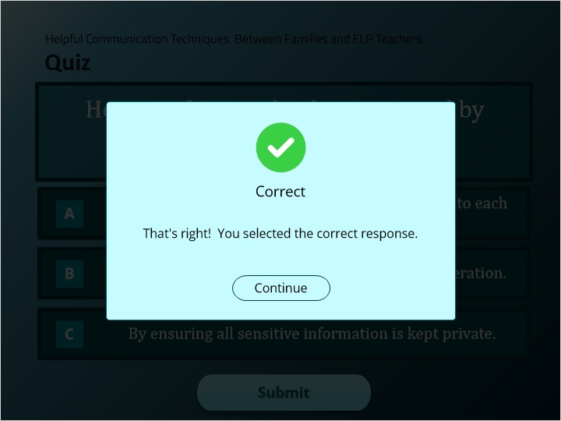

## 2.25 Quiz

*(Pick One, 10 points, 2 attempts permitted)*

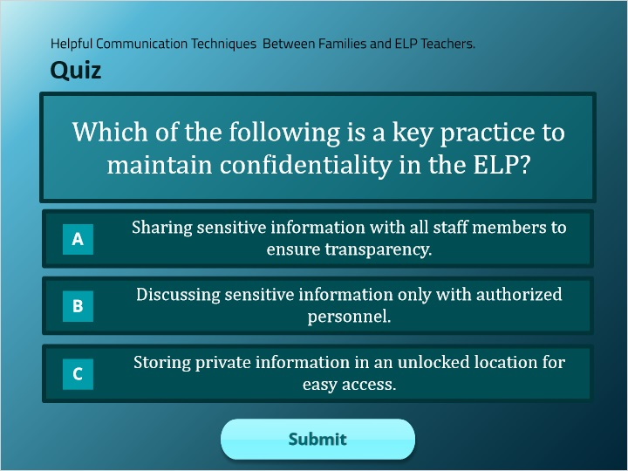

| Correct | Choice |
| --- | --- |
| Group 1 |  |
| Group 2 | X |
| Group 3 |  |

**Feedback when correct:**

That's right! You selected the correct response.

**Feedback when incorrect:**

You did not select the correct response.

**Notes:**

### Try Again (Slide Layer)

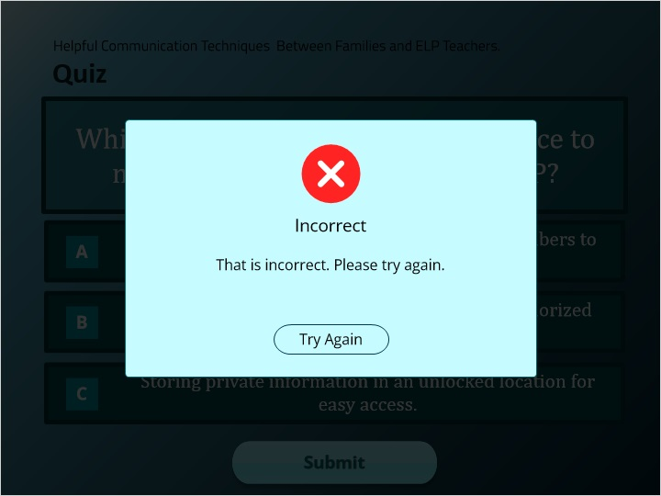

### Incorrect (Slide Layer)

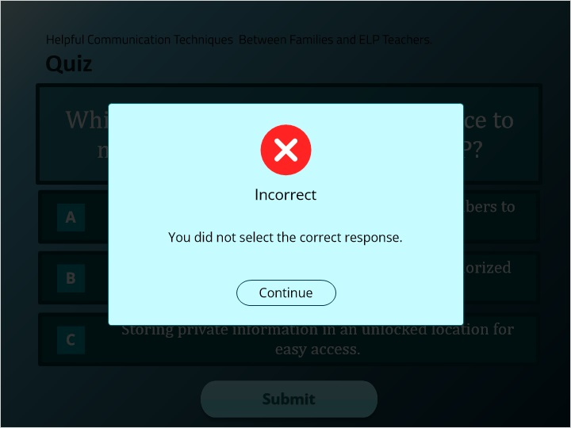

### Correct (Slide Layer)

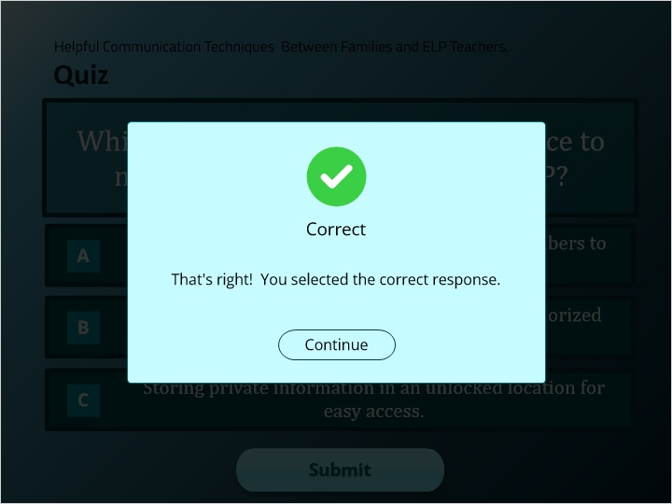

## 2.26 Quiz

*(Pick One, 10 points, 2 attempts permitted)*

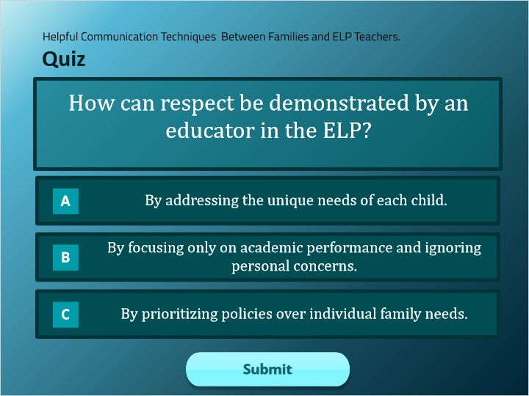

| Correct | Choice |
| --- | --- |
| Group 1 | X |
| Group 2 |  |
| Group 3 |  |

**Feedback when correct:**

That's right! You selected the correct response.

**Feedback when incorrect:**

You did not select the correct response.

**Notes:**

### Try Again (Slide Layer)

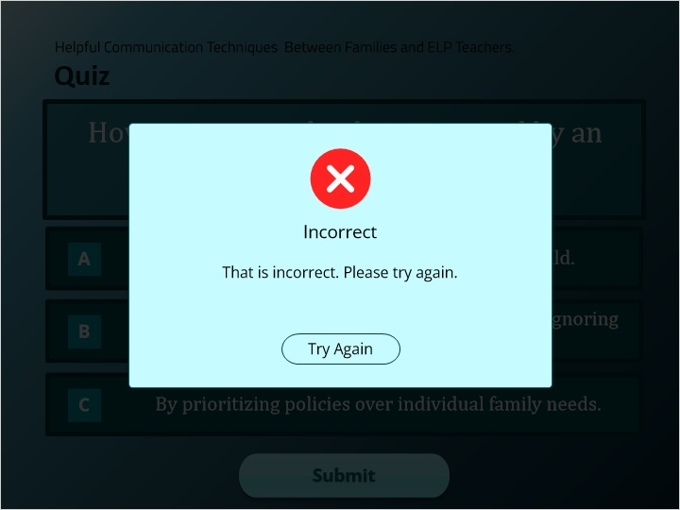

### Incorrect (Slide Layer)

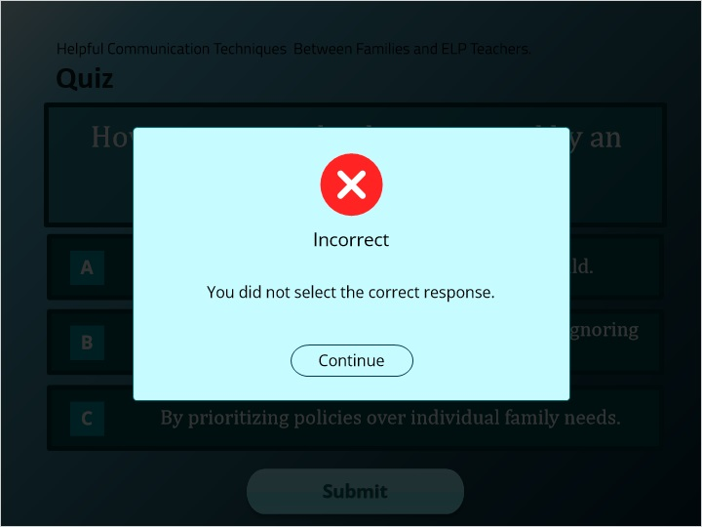

### Correct (Slide Layer)

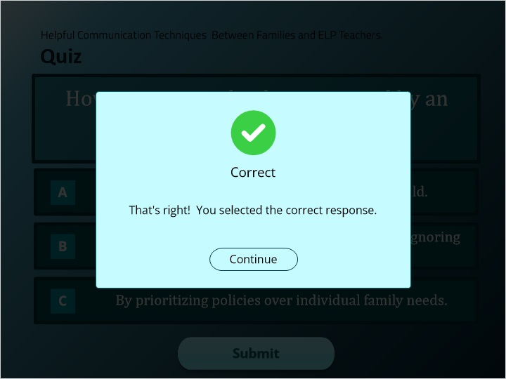

## 2.27 QUIZ RESULTS

*(Results Slide, 0 points, 1 attempt permitted)*

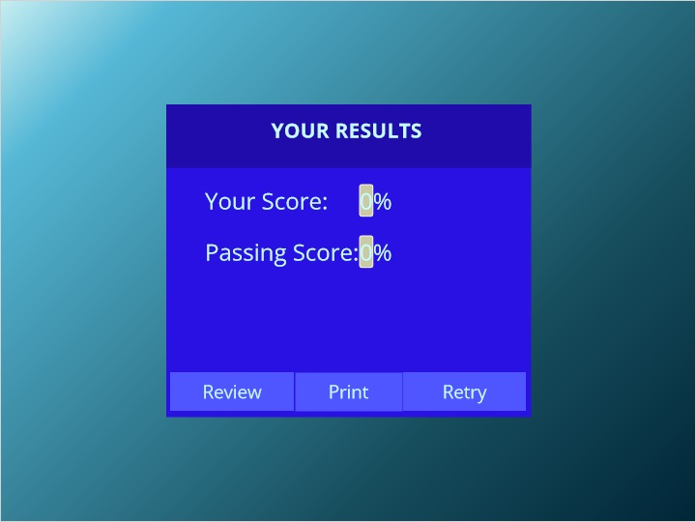

| Results for |
| --- |
| 2.13 True or False |
| 2.14 Quiz |
| 2.15 Quiz |
| 2.16 True or False |
| 2.22 Quiz |
| 2.23 Quiz |
| 2.24 Quiz |
| 2.25 Quiz |
| 2.26 Quiz |

| Result slide properties | Passing Score |
| --- | --- |
| 80% |

**Notes:**

### Failure (Slide Layer)

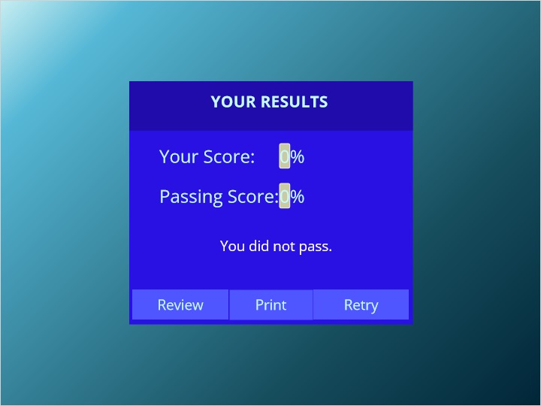

### Success (Slide Layer)

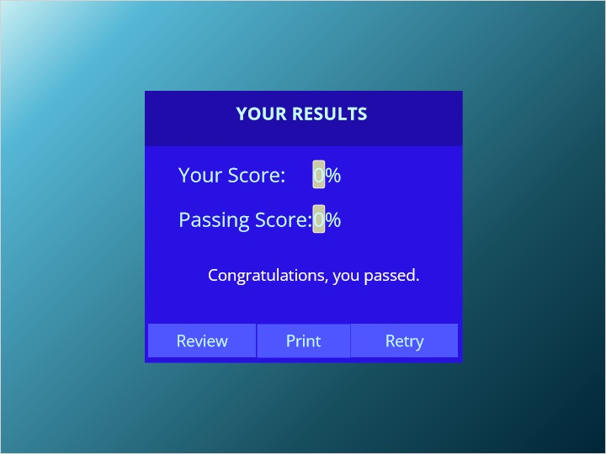

## 2.28 Title

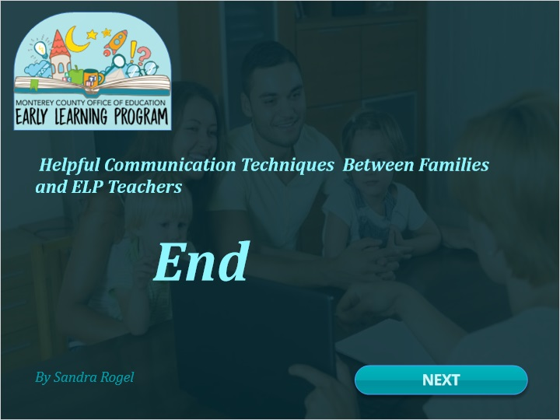

# 3. Mod 3

## 3.1 Title

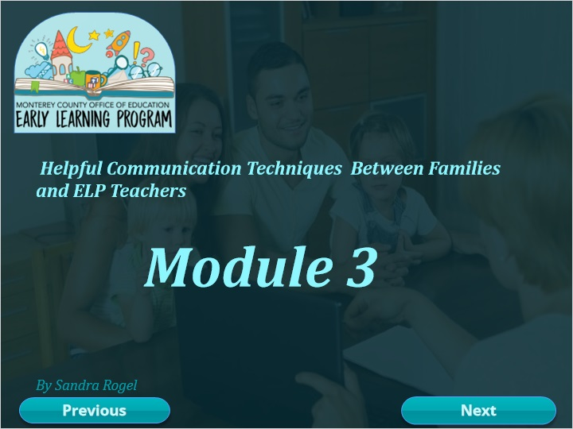

## 3.2 Course Structure

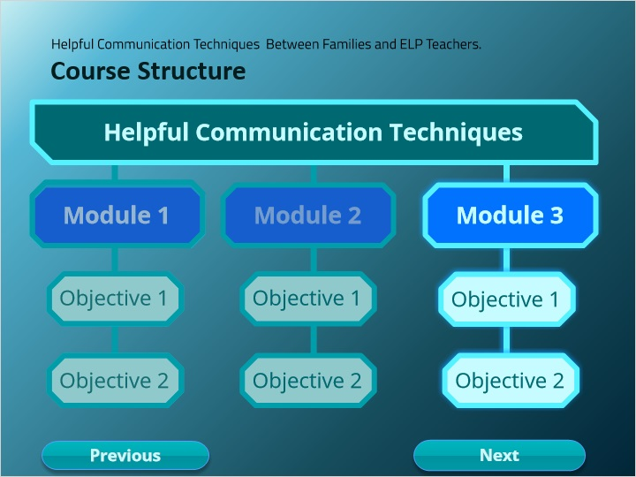

## 3.3 Learning Objectives 5 & 6

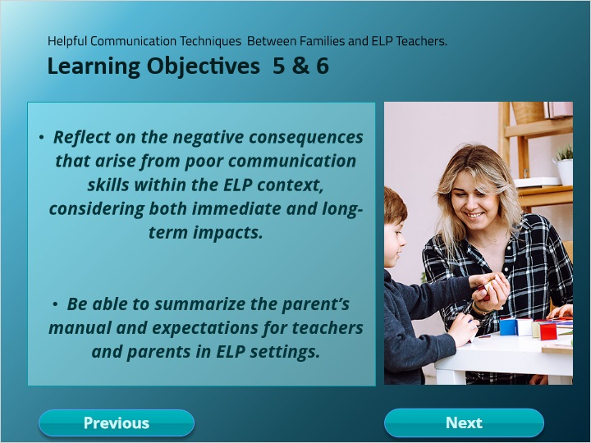

**Notes:**

## 3.4 Module 3

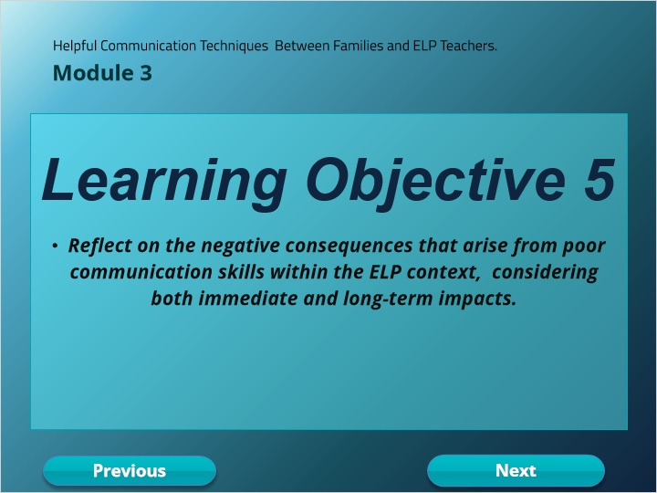

## 3.5 Learning Objective 5

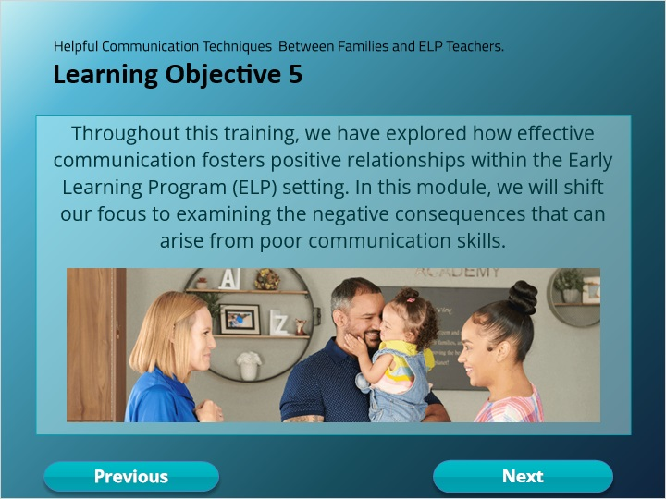

## 3.6 Interactions with Parents and Guardians

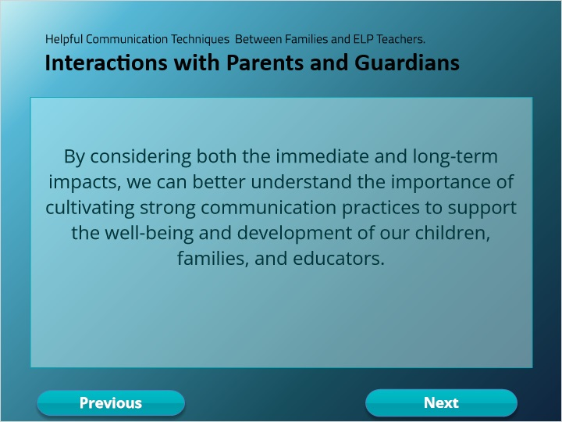

### Layer 1 (Slide Layer)

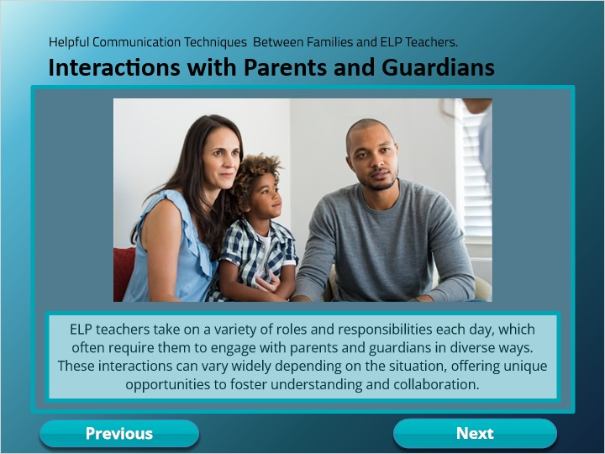

## 3.7 Negative Consequences

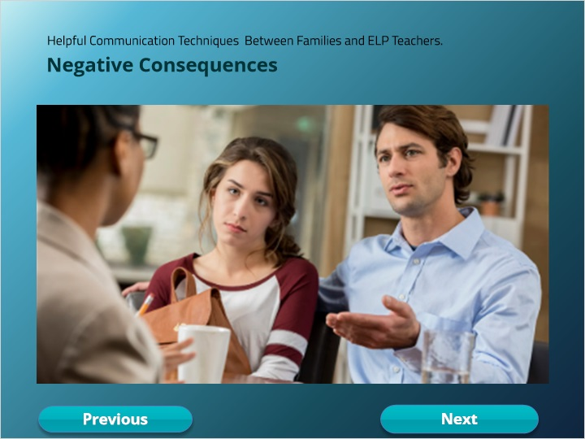

### Conflict (Slide Layer)

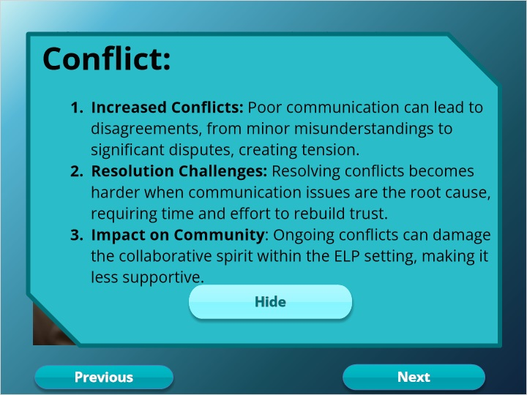

### Diminished Trust (Slide Layer)

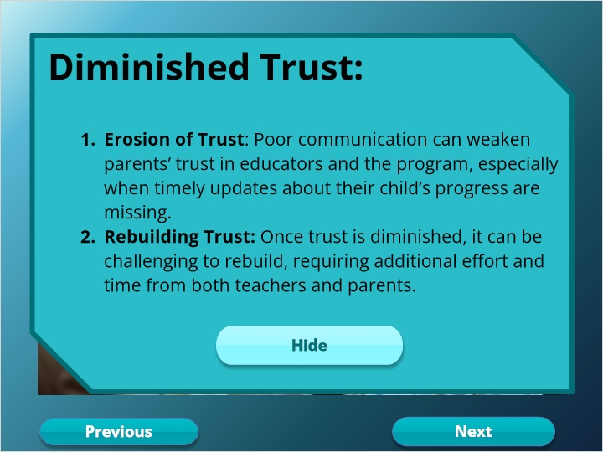

### Increased Stress (Slide Layer)

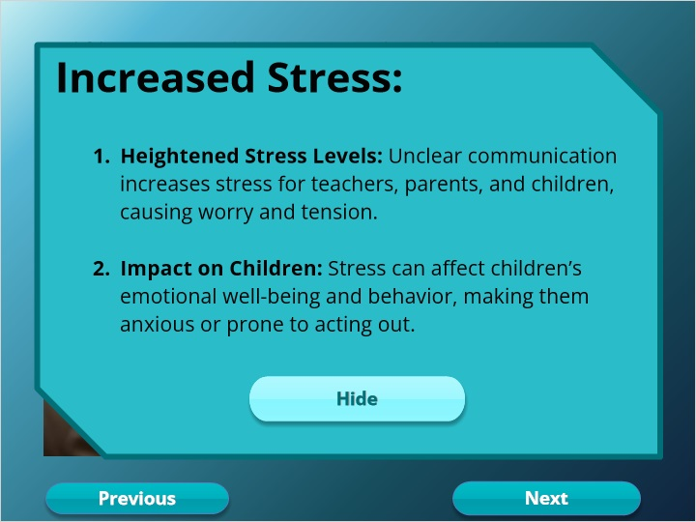

### Misunderstandings (Slide Layer)

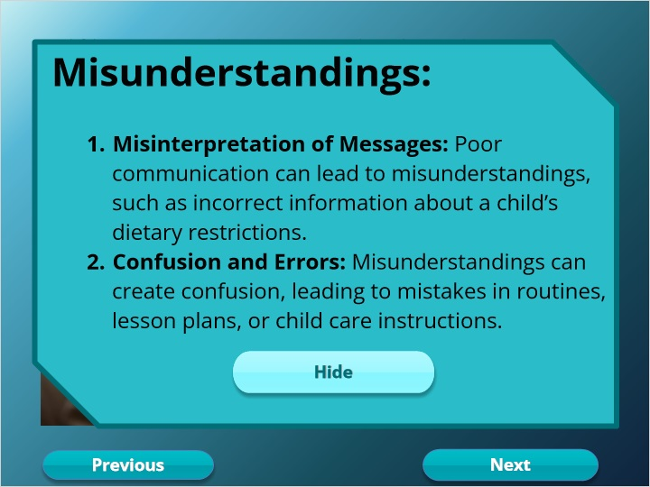

## 3.8 Immediate Negative Consequences

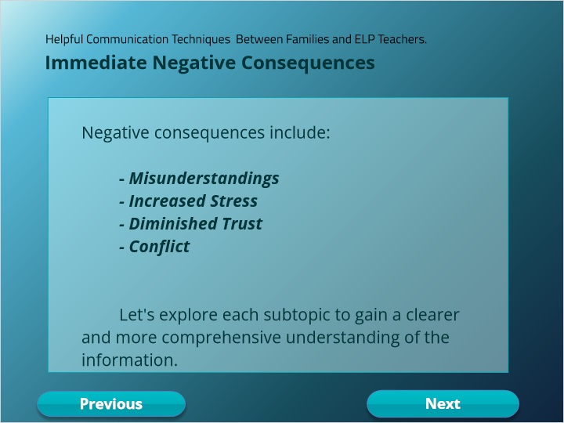

## 3.9 Immediate Negative Consequences

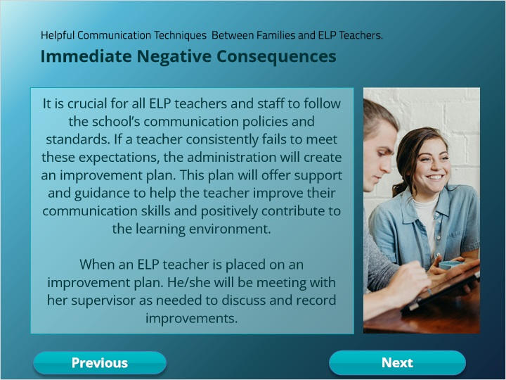

## 3.10 Improvment Plan

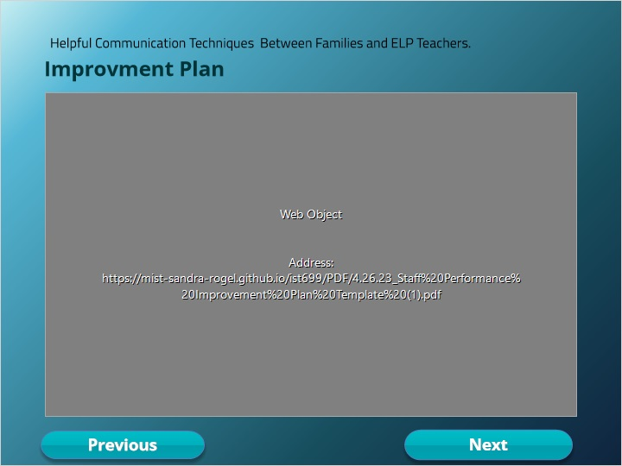

## 3.11 Long-Term Consequences for Parents and Educators

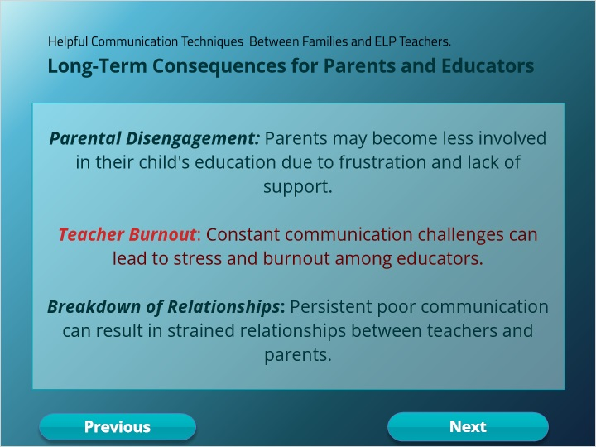

## 3.12 Improvement plan Long-Term Effects

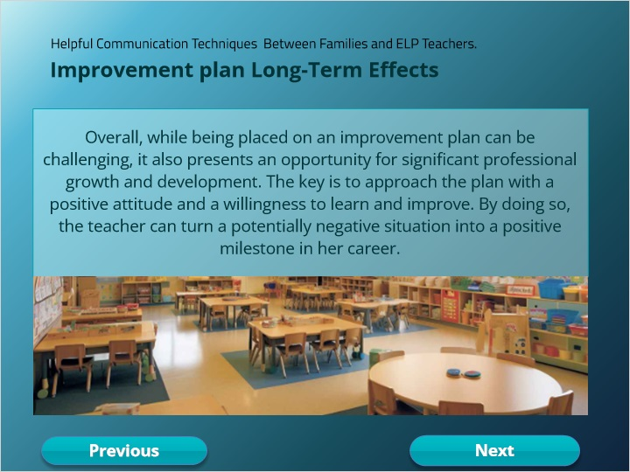

## 3.13 Improvement plan Long-Term Effects

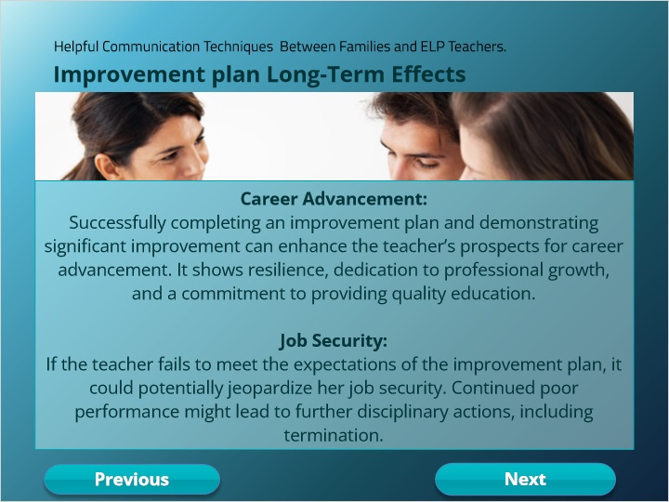

## 3.14 Quiz

*(Pick One, 10 points, 2 attempts permitted)*

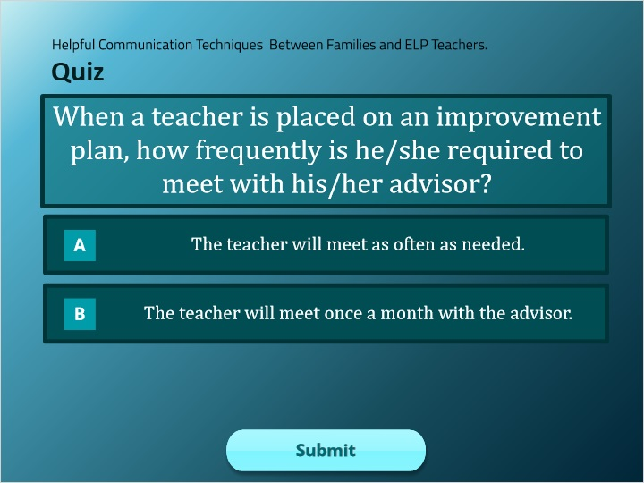

| Correct | Choice |
| --- | --- |
| Group 1 | X |
| Group 2 |  |

**Feedback when correct:**

That's right! You selected the correct response.

**Feedback when incorrect:**

You did not select the correct response.

**Notes:**

### Try Again (Slide Layer)

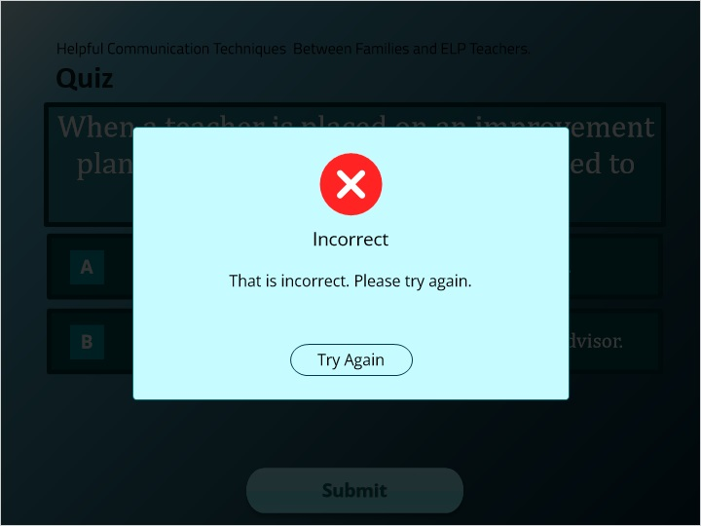

### Incorrect (Slide Layer)

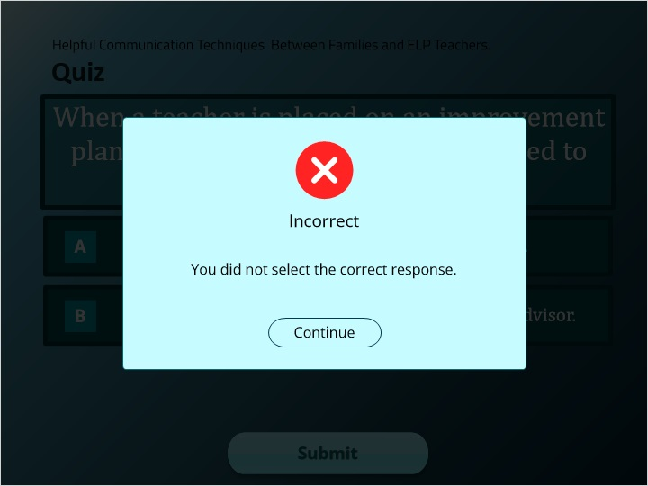

### Correct (Slide Layer)

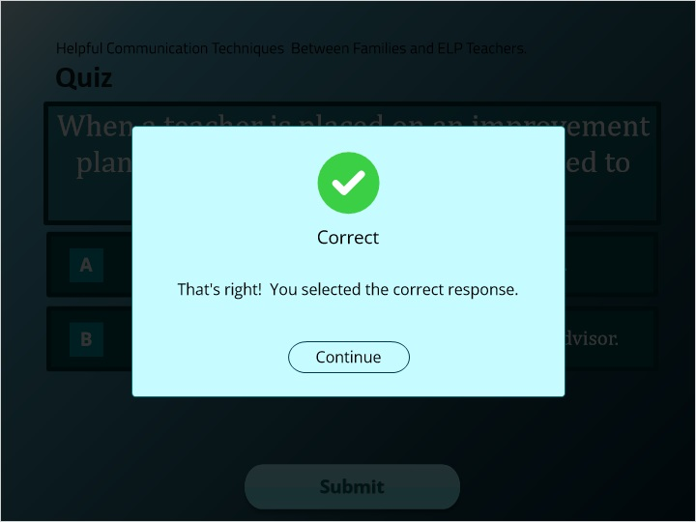

## 3.15 Preventing Negative Consequences

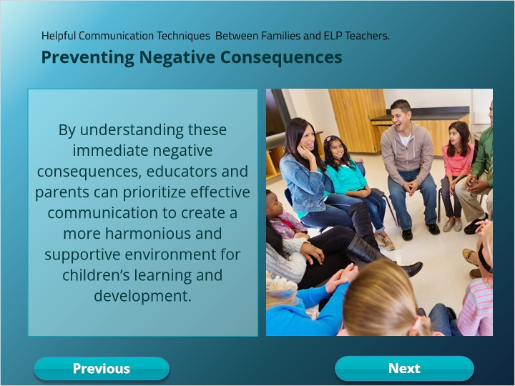

## 3.16 Preventing Negative Consequences

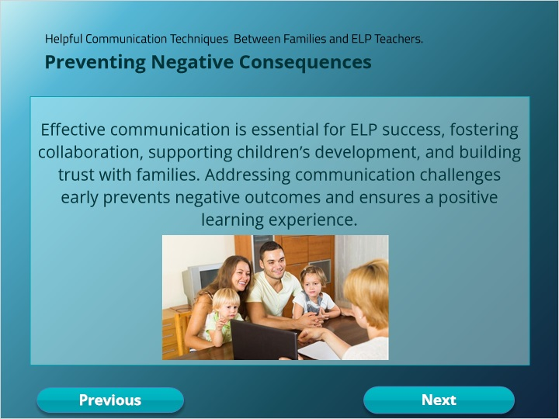

## 3.17 Module 3

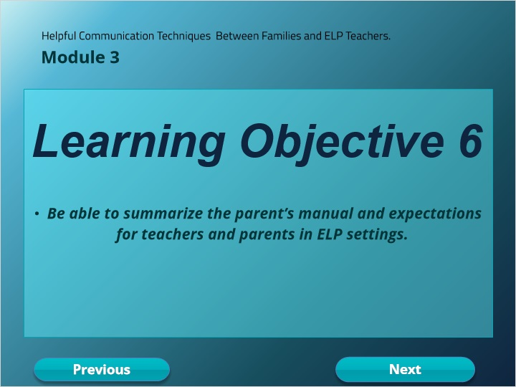

## 3.18 Parent’s Manual

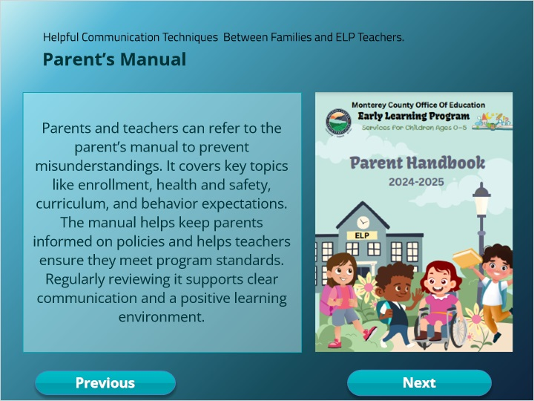

### Parent Handbook (Slide Layer)

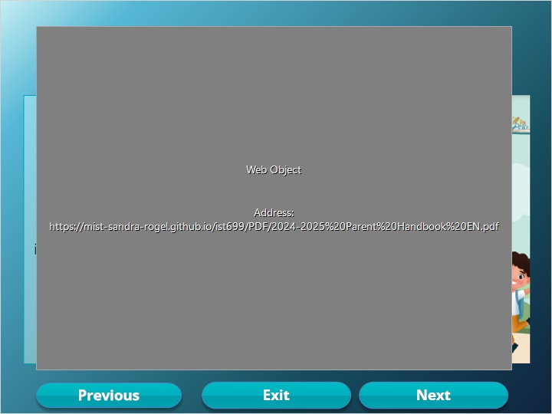

## 3.19 Content Summary

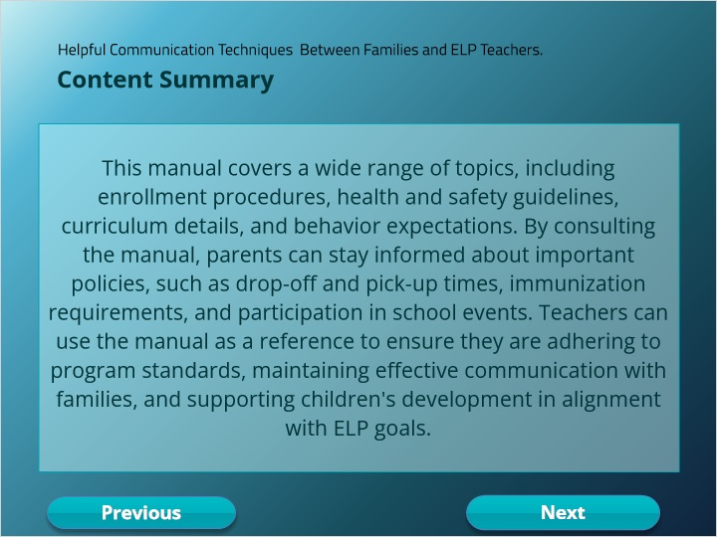

## 3.20 Frequent Topics

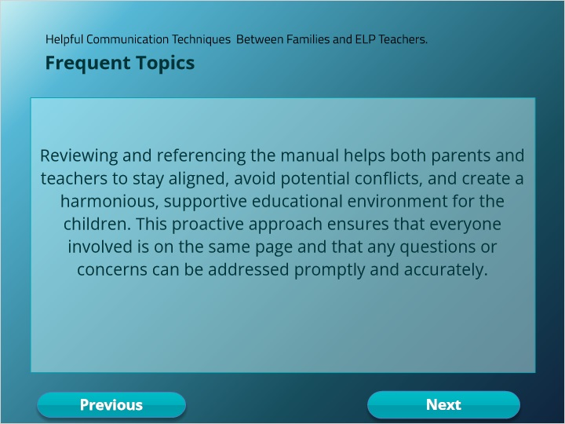

## 3.21 Quiz

*(Pick One, 10 points, 2 attempts permitted)*

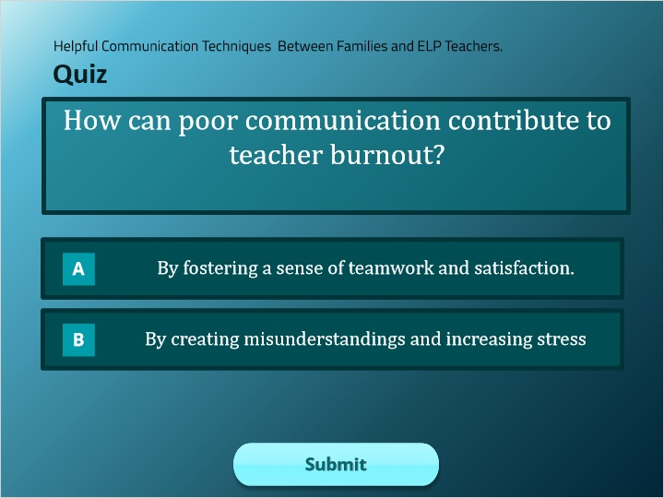

| Correct | Choice |
| --- | --- |
| Group 1 |  |
| Group 2 | X |

**Feedback when correct:**

That's right! You selected the correct response.

**Feedback when incorrect:**

You did not select the correct response.

**Notes:**

### Try Again (Slide Layer)

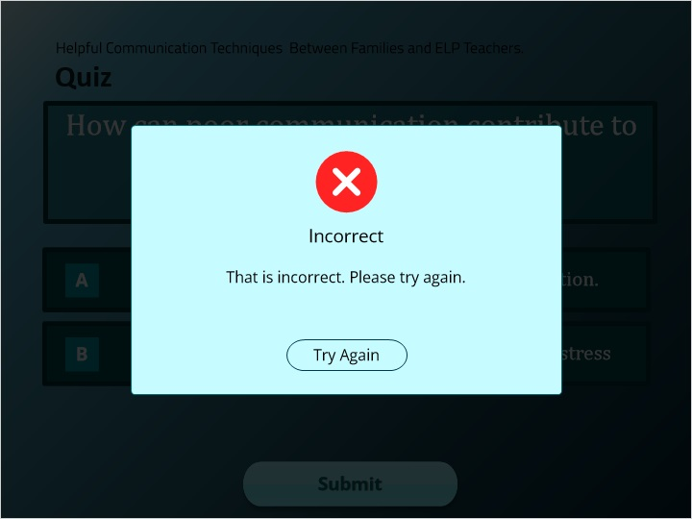

### Incorrect (Slide Layer)

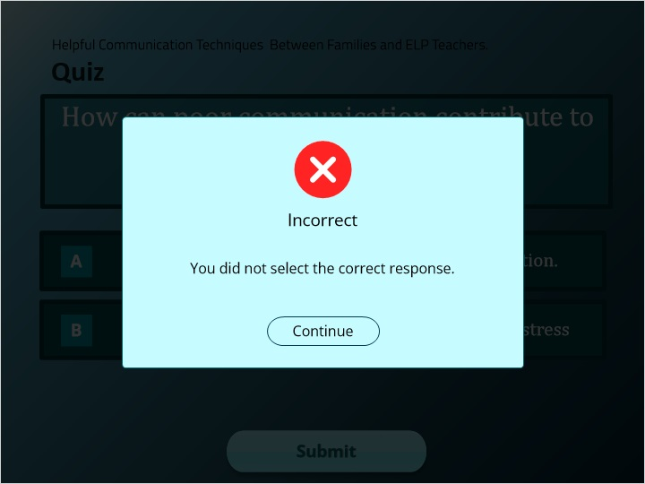

### Correct (Slide Layer)

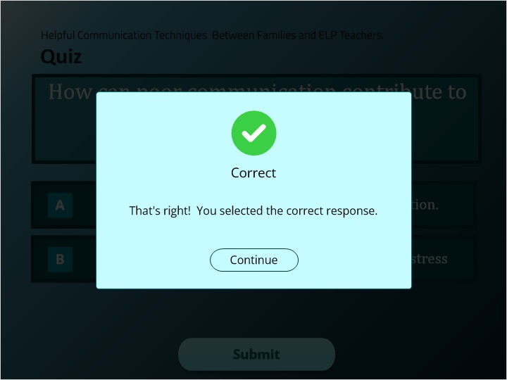

## 3.22 Quiz

*(Pick One, 10 points, 2 attempts permitted)*

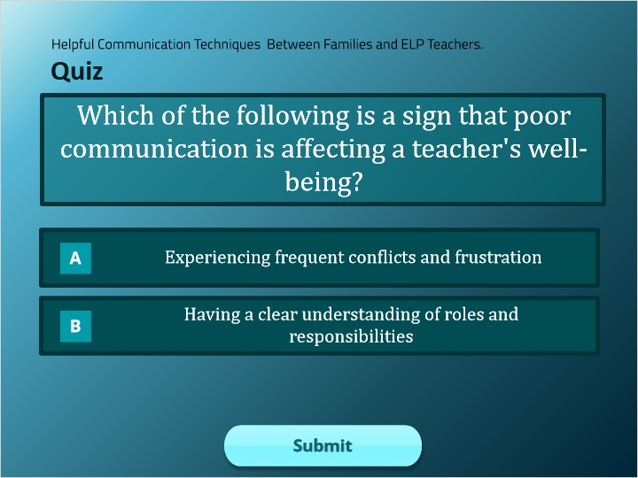

| Correct | Choice |
| --- | --- |
| Group 1 | X |
| Group 2 |  |

**Feedback when correct:**

That's right! You selected the correct response.

**Feedback when incorrect:**

You did not select the correct response.

**Notes:**

### Try Again (Slide Layer)

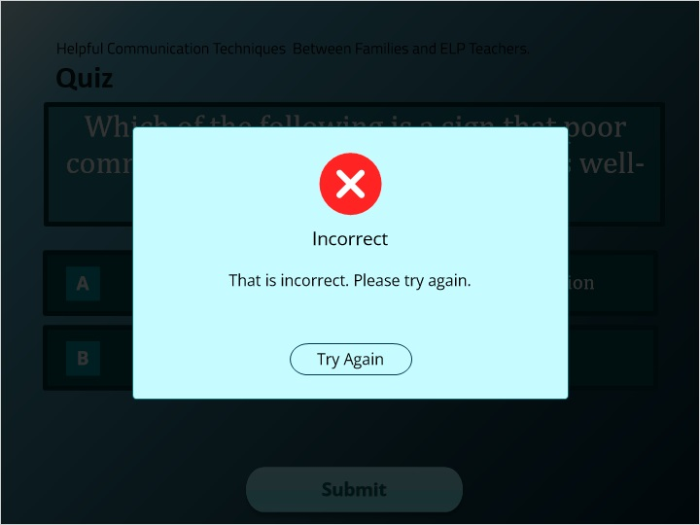

### Incorrect (Slide Layer)

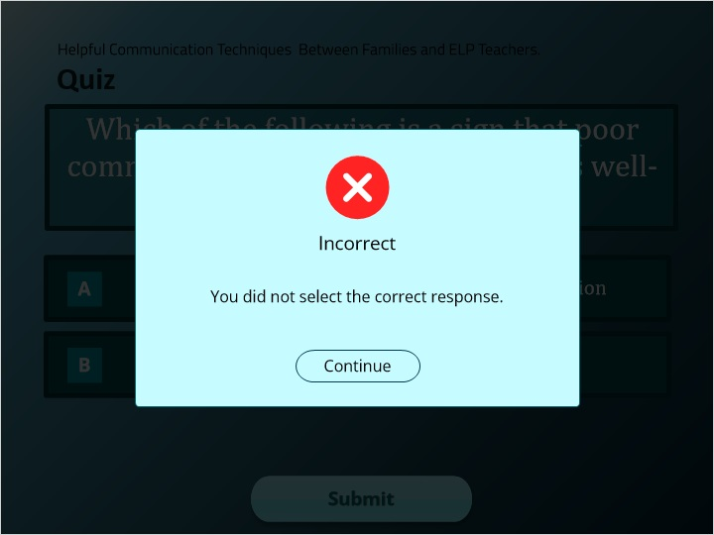

### Correct (Slide Layer)

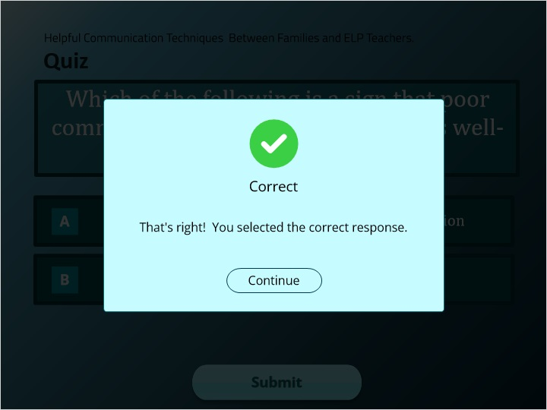

## 3.23 QUIZ RESULTS

*(Results Slide, 0 points, 1 attempt permitted)*



| Results for |
| --- |
| 3.14 Quiz |
| 3.21 Quiz |
| 3.22 Quiz |

| Result slide properties | Passing Score |
| --- | --- |
| 80% |

**Notes:**

### Failure (Slide Layer)



### Success (Slide Layer)



## 3.24 Resources

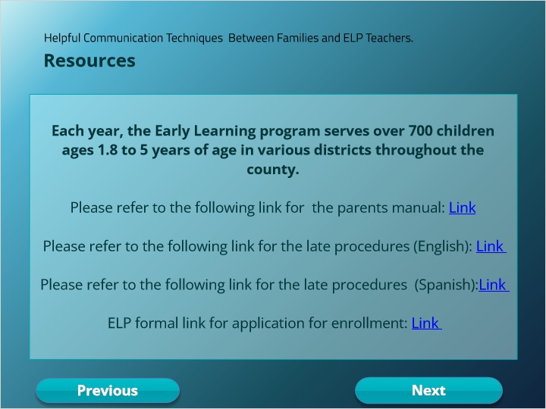

## 3.25 Title

